SUBCOURSE EDITION
IT 0425 B

US ARMY INTELLIGENCE CENTER

INTRODUCTION TO BATTLEFIELD
TECHNICAL INTELLIGENCE
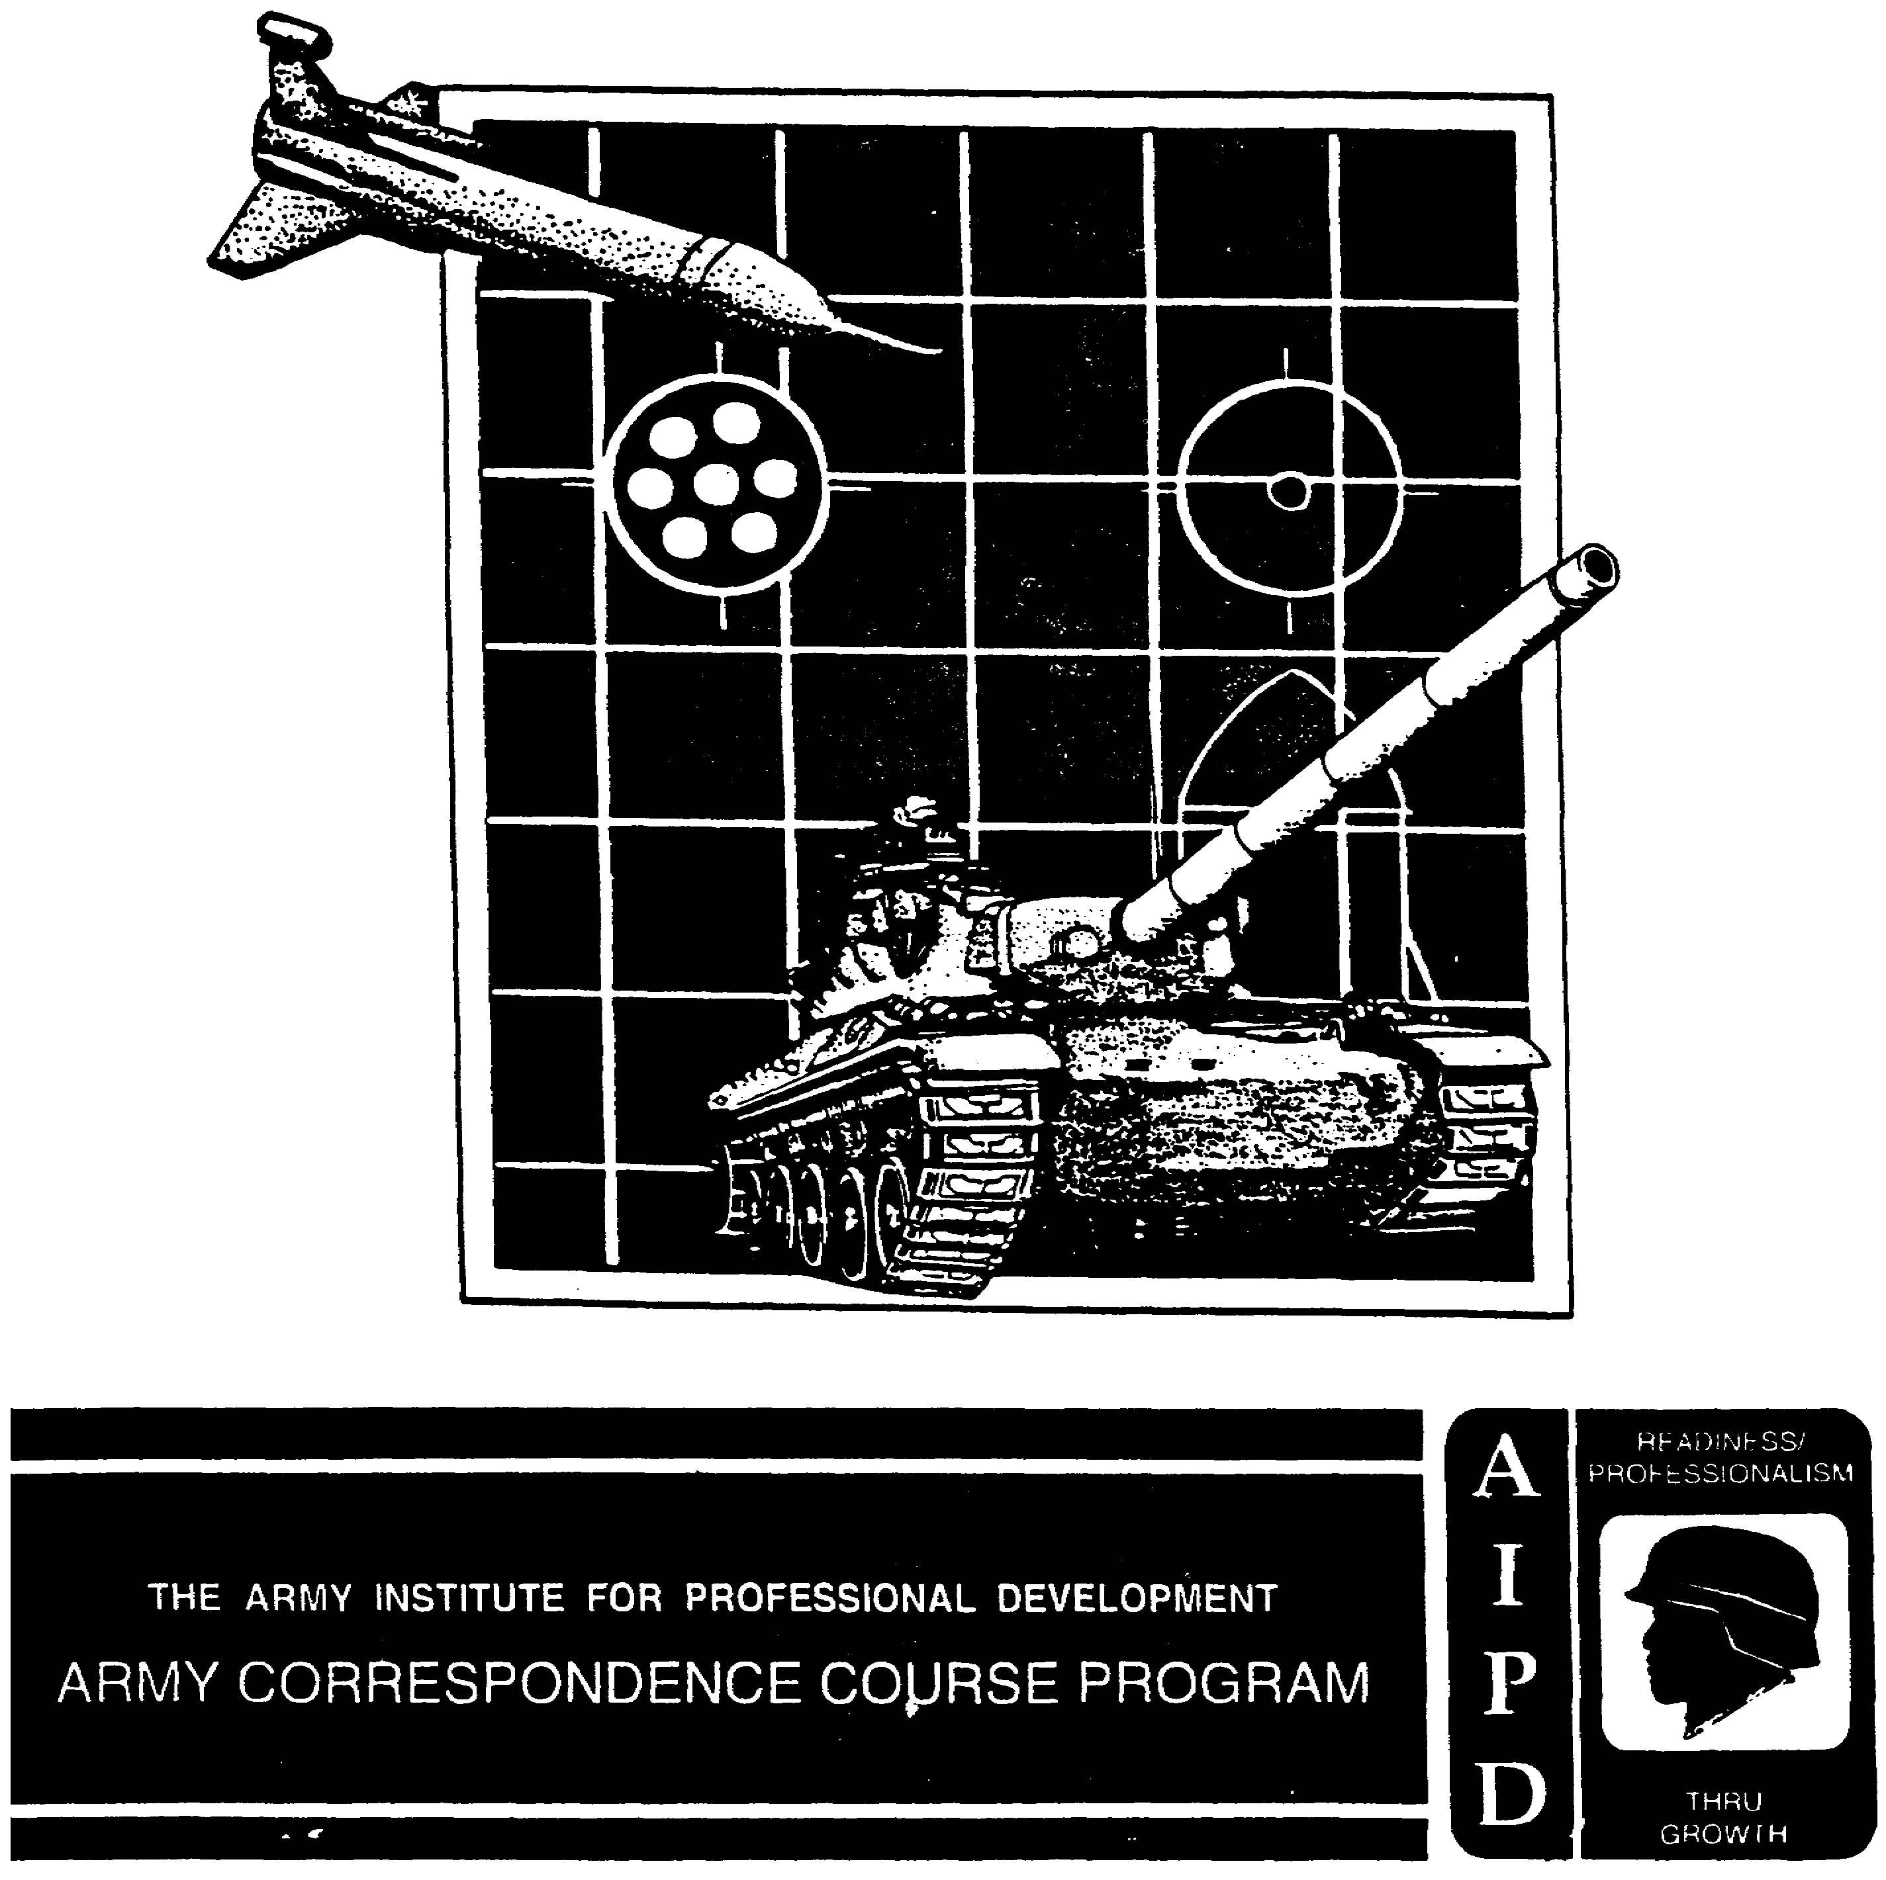

INTRODUCTION TO BATTLEFIELD
TECHNICAL INTELLIGENCE

Subcourse Number IT 0425

EDITION B

US Army Intelligence Center
Fort Huachuca, AZ 85613-6000

6 Credit Hours

Edition Date: January 1998

SUBCOURSE OVERVIEW

This subcourse is designed to teach you about Battlefield Technical Intelligence (TECHINT) as it applies to Military Intelligence (MI). Contained within this subcourse are instructions on TECHINT definitions, mission, organization, responsibilities, and operations of TECHINT elements.

There are no prerequisites for this subcourse.

This subcourse reflects the doctrine which was current at the time the subcourse was prepared. In your own work situation, always refer to the latest publications.

The words "he," "him," and "men," when used in this publication, represent both the masculine and feminine gender unless otherwise states.

TERMINAL LEARNING OBJECTIVE

TASK: You will know the parts of the TECHINT system and explain their functions, the activities involved and their role in reporting, handling, and exploiting TECHINT materiels.

CONDITIONS: You will be given narrative information and illustrations from FM 34-54.

STANDARD: You will know the TECHINT mission in peacetime and wartime in accordance with FM 34-54.

i IT 0425

TABLE OF CONTENTS

SECTION Page

Subcourse Overview i

LESSON 1: Battlefield Technical Intelligence 1-1

Introduction 1-1
The Raid on Bruneval 1-2
Definition 1-3
Practice Exercise 1 1-10
Answer Key and Feedback 1-12

LESSON 2: Battlefield TECHINT Responsibilities 2-1

Introduction 2-1
Staff Officers 2-2
Special Staff Officers 2-5
Practice Exercise 2-13
Answer Key and Feedback 2-14

LESSON 3: Battlefield TECHINT Operations 3-1

Introduction 3-1
Battlefield TECHINT Basic Objectives 3-2
Practice Exercise 3-23
Answer Key and Feedback 3-24

APPENDIX: ACRONYM LIST A-1

IT 0425 ii

LESSON 1

BATTLEFIELD TECHNICAL INTELLIGENCE

CRITICAL TASKS: 301-337-1321
301-337-1324
301-337-1325
301-373-3160

OVERVIEW

TASK DESCRIPTION:

In this lesson you will learn the definition of TECHINT, the mission of TECHINT, how it is organized, and its functions.

LEARNING OBJECTIVE:

ACTIONS: Describe TECHINT, its mission, how it is organized, and its functions.

CONDITIONS: You will be given narrative information and illustrations from FM 34-54.

STANDARDS: You will describe the mission, organization, and functions of the TECHINT elements in accordance with FM 34-54.

REFERENCES: The material contained in this lesson was derived from the following reference:

FM 34-54.

INTRODUCTION

The raid on Bruneval is an example of how valuable TECHINT can be to the combat commander. It provides the commander with information on what he is up against and if there are countermeasures available (see Figure 1-1 for a discussion of the Bruneval raid).

The TECHINT system is made up of two parts: Scientific and Technical Intelligence (S&TI) and Battlefield TECHINT. S&TI supports national level authorities (strategic echelon decision makers); while Battlefield TECHINT supports the operational and tactical levels of war intelligence (theater, corps, and division commanders).

1-1 IT 0425

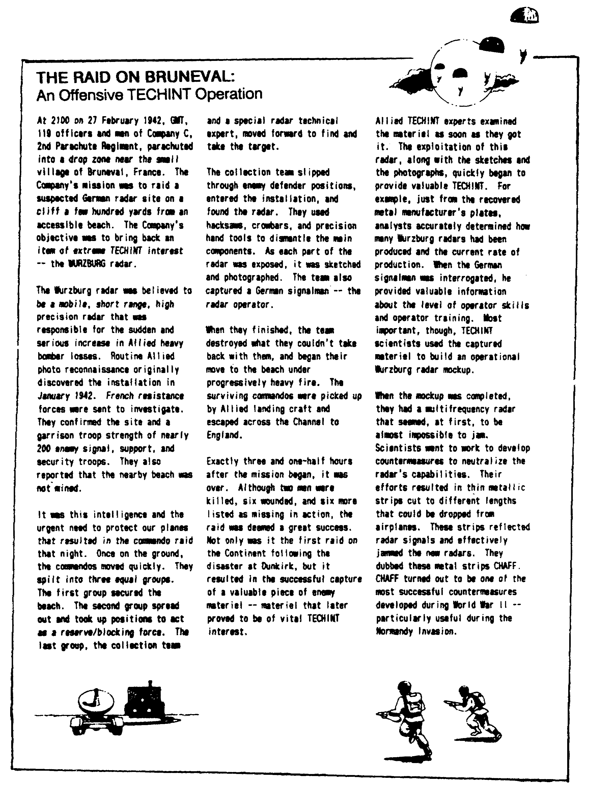

Figure 1-1. The Raid on Bruneval.

IT 0425 1-2

DEFINITION

TECHINT is the end products of a complex process. It is the result of collecting, analyzing and processing information on foreign material and its operational capabilities. It is also the result of studing the performance of foreign material and its operational capabilities.

Foreign material is the all-encompassing term for the weapon systems, equipment, apparatus, documents, and supplies of a foreign military force or nonmilitary organization. TECHINT, in its broadest senses, may or may not have military applications.

MISSION

The mission of US Army elements producing technical intelligence is to support the tactical commander's effort to fight and win the Battlee. Through the collection, processing, and dessemination of scientific and technical information and data, the combat commander uses TECHNINT analysts and TECHINT products to identify and counter an adversary's momentary technological advantage.

ORGANIZATION

The Army's TECHINT organization begins with the individual soldier. TECHINT collection usually starts with one conscientious soldier finding something new or unusual on the battlefield and taking the proper steps to report it. Succeeding higher levels then exploit the information or item until they produce a countermeasure to neutralize the enemy's technological advantage. While it is true that a single weapon or technology seldom means the difference between final victory or defeat, it can give one side a decisive battlefield advantage.

Within the Department of Defense (DOD), two parts of the overall TECHINT system are task organized for military TECHINT collection: the S&TI community and the Battlefield TECHINT assets of the U.S. Army. The S&TI community focuses on the TECHINT requirements of strategic policy and decision makers. The battlefield TECHINT community serves the commander's intelligence requirements at the operational and tactical levels.

1. Scientific and Technical Intelligence Structure. Elements of the DOD perform military S&TI activities for the US Government. The S&TI community handles the nation's overall TECHINT needs during peacetime, and the strategic TECHINT requirements in wartime. Figure 1-2 shows DOD intelligence activities with S&TI and TECHINT functions and authority.

a. Defense Intelligence Agency (DIA). The DIA through its S&TI directorate manages and reviews overall TECHINT activities throughout DOD.

b. Armed Forces Medical Intelligence Center (AFMIC). The AFMIC is a DOD production center responsible for exploiting foreign medical materiel. AFMIC missions includes: Studies and reports foreign medical S&TI and general medical intelligence to DOD and other federal agencies, foreign biological warfare S&TI capabilities, the DOD Foreign Medical Materiel Exploitation Program, and "Quick Response" foreign medical intelligence support.

1-3 IT 0425

c. Air Force Foreign Technology Division (FTD). The FTD, Air Force Systems Command, is the primary DOD agency for producing foreign aerospace S&TI.

d. Naval Technical Intelligence Center (NTIC). The NTIC is the Navy's proponent for TECHINT. It provides S&TI on technical characteristics and capabilities of foreign naval forces and merchant systems.

e. Office of the Deputy Chief of Staff for Intelligence (ODCSINT) US Army. Even though this office does not produce intelligence it does have general staff responsibility for all Army TECHINT activities. ODCSINT formulates policies and procedures for S&TI activities, supervises and executes the Army S&TI program, coordinates Department of the Army (DA) staff and major subordinate command requirements for TECHINT and is responsible for the Army Foreign Materiel Program (FMP).

2. Army Scientific and Technical Intelligence Organization.

a. Army Intelligence Agency (AIA). The AIA is a field operating agency of the ODCSINT. The AIS mission is to produce and disseminate intelligence on foreign ground forces, ground force systems, and related sciences and technologies in response to DA and DOD requirements. AIA provides threat analysis and related projections to the Army combat development community to support force modernization programs.

b. The AIA commander is also the Assistant Deputy Chief of Staff for Intelligence (ADCSINT); managing the Army FMP as well as executing the Foreign Materiel Exploitation Program (FMEP) for the Deputy Chief of Staff, Intelligence (DCSINT). The AIA is composed of three Army Intelligence production centers: The Army Intelligence and Threat Analysis Center (ITAC); the Foreign Science and Technology Center (FSTC); and the Missile and Space Intelligence Center (MSIC). FSTIC and MSIC are the Army's S&TI centers.

(1) Army Intelligence and Threat Analysis Center (ITAC). The ITAC is part of the United States Army Intelligence Agency (USAIA). It produces comprehensive, general intelligence and counterintelligence analysis on the capabilities, vulnerabilities, and threat posed by, or projected for foreign ground and security forces. These analyses emphasize from a tactical and doctrinal standpoint how the threat uses key systems.

(2) The Army Foreign Science and Technology Center (FTSC). The FTSC is subordinate to the AIA. It produces and maintains intelligence on foreign scientific developments, ground force weapon systems, and technologies (less missiles and medical). The FSTC analyzes: Military communications and electronic (C-E), types of aircraft used by foreign ground forces, scientific research and development activities, and nuclear, biological and chemical (NBC) warfare and other military research.

IT 0425 1-4

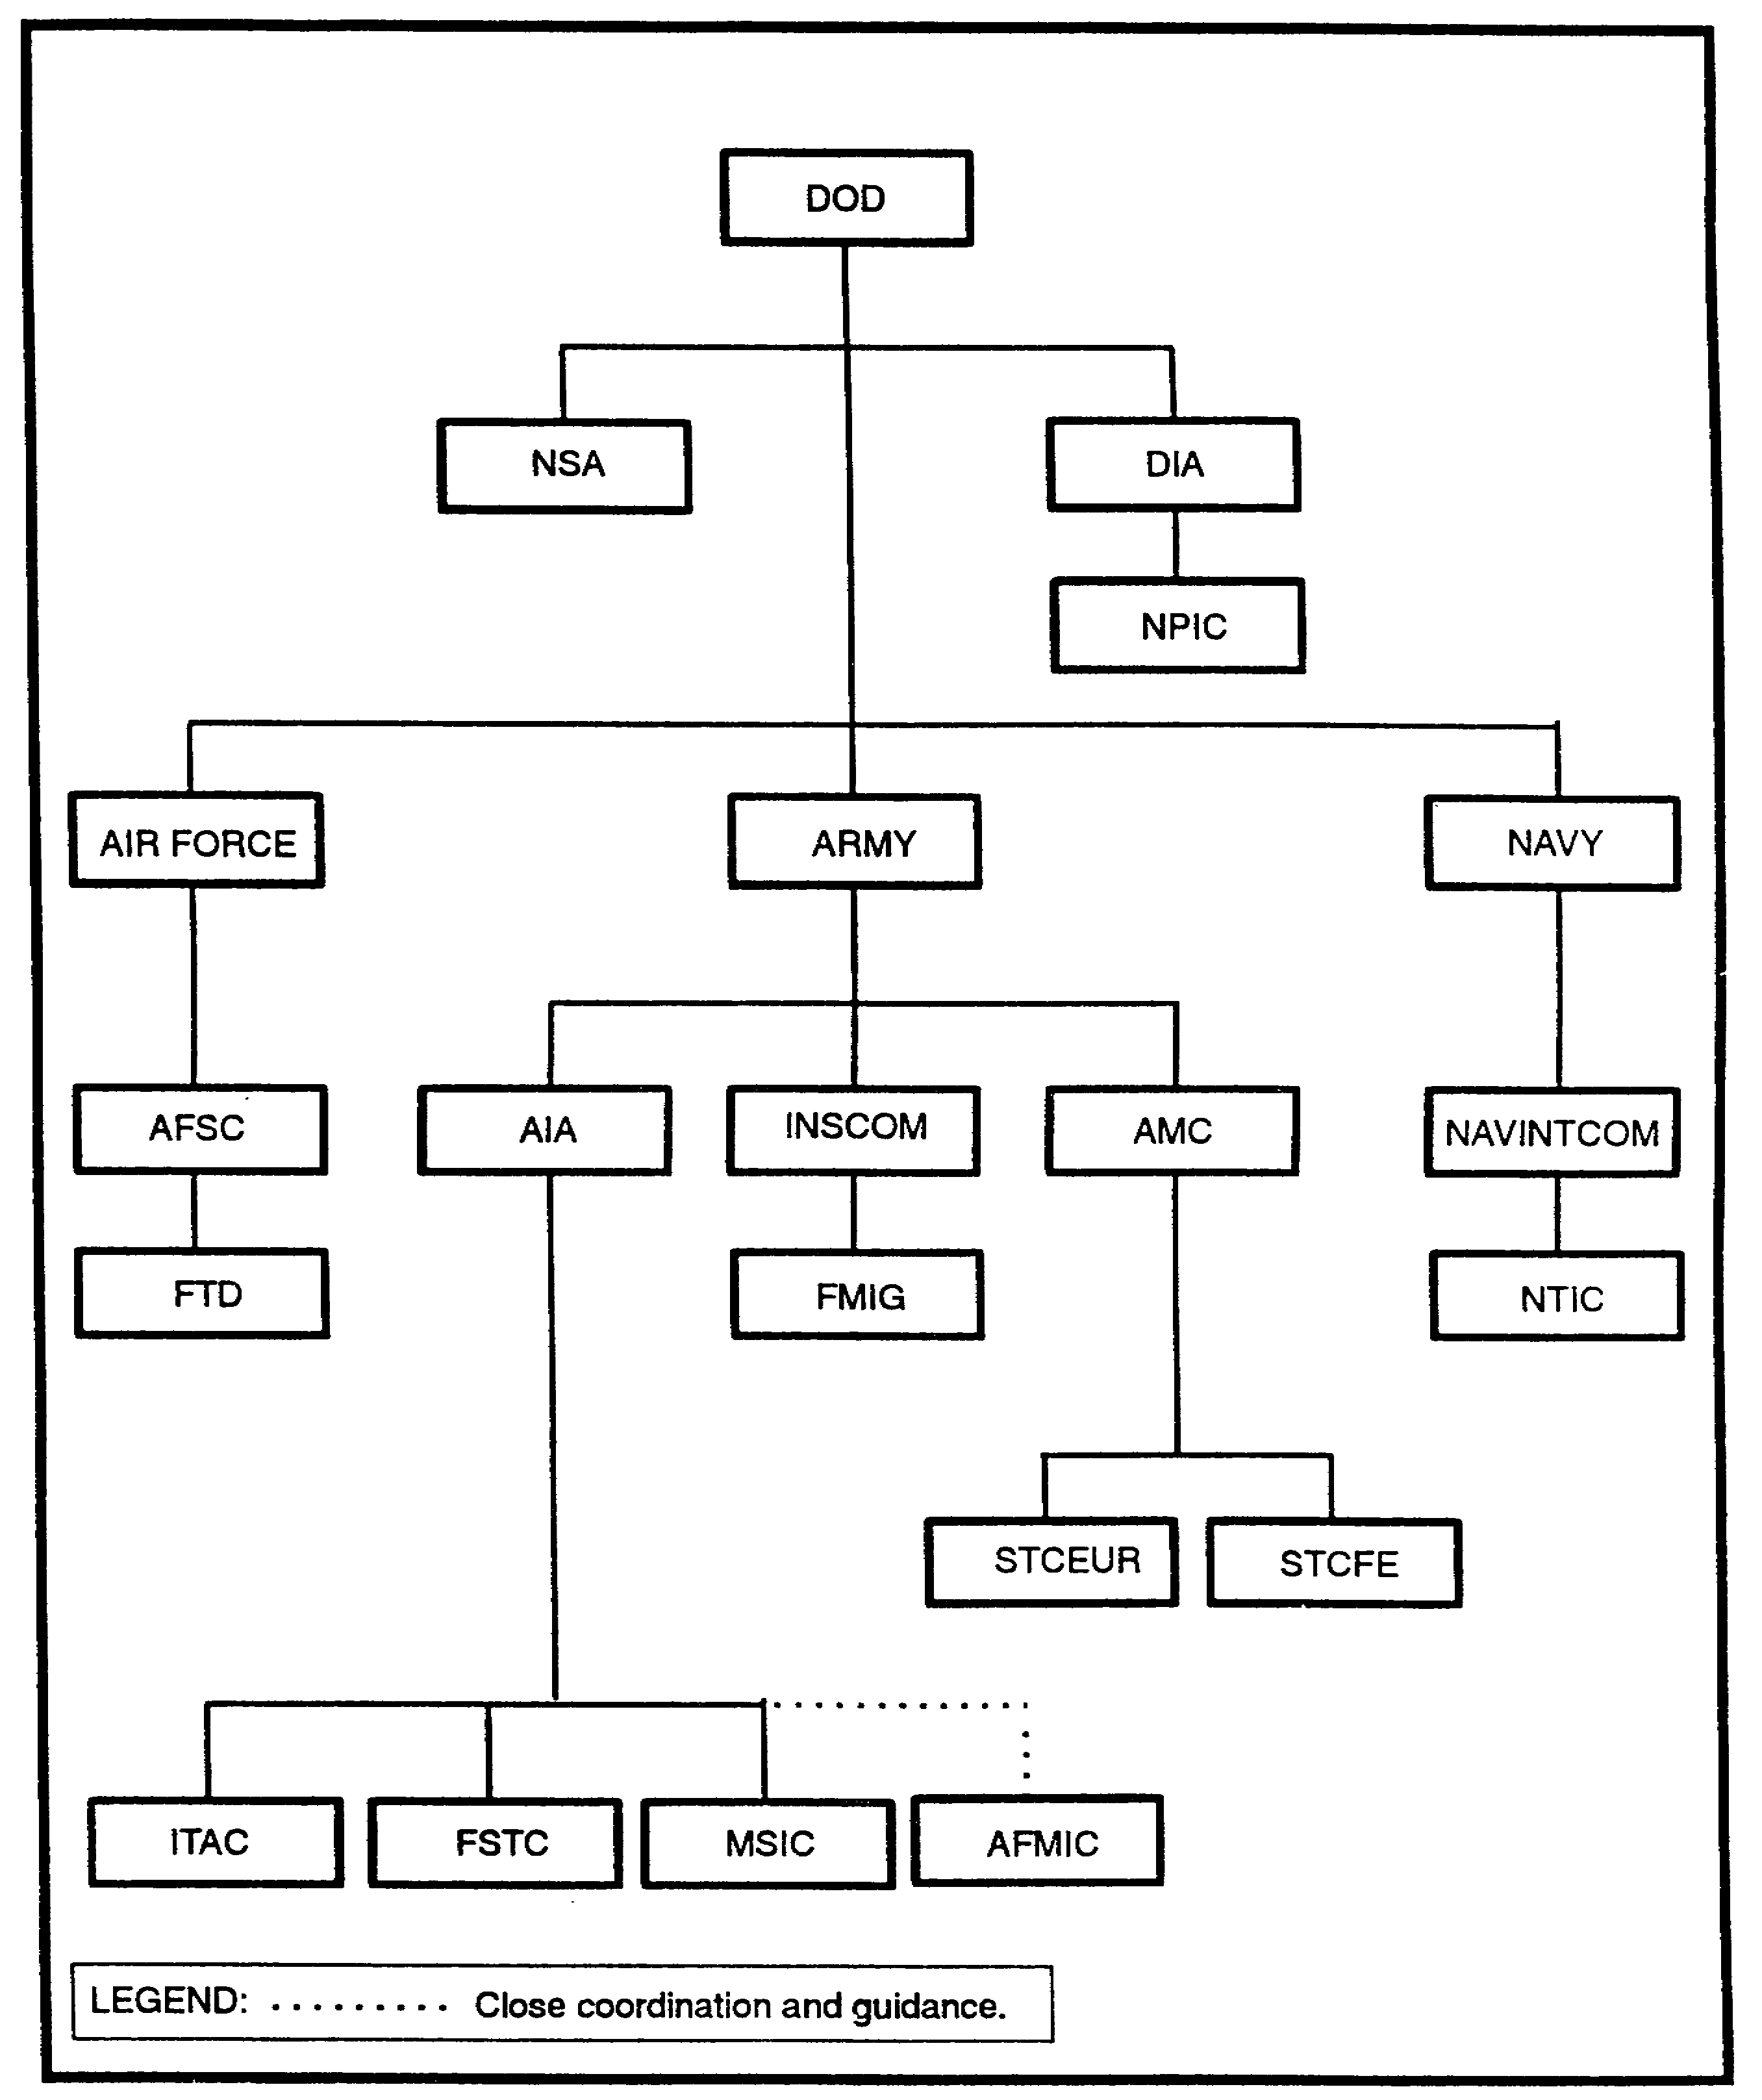

Figure 1-2. The Department of Defense S&TI community.

1-5 IT 0425

(3) The Army Missile and Space Intelligence Center (MSIC). MSIC is also subordinate to the AIA. It acquires, produces, maintains, and disseminates S&TI pertaining to missile and space weapon systems, subsystems, components, and activities. This S&TI represents state-of-art technology and supports DA and DOD strategic intelligence production as well as the FMEP. The MSIC analyzes--

- Foreign antiparticle missiles.

- Antisatellite technology.

- Short-range ballistic missiles.

- Antitank guided missiles.

The MSIC plans, organizes, and manages a unique form of threat support: The Army development and acquisition of threat simulators. These simulators support training and doctrine command (TRADOC) and system program managers during the operational and training phases of new US systems. They provide a visual and technological replication of the battlefield threat, when the actual foreign materiel cannot be acquired or is too costly to buy.

c. The Army Materiel Command (AMC). The AMC shares responsibility for managing the overt acquisition of foreign materiel for TECHINT purposes. AMC buys foreign materiel domestically as well as through its centers in Europe and the Far East. Through this program, the AMC also supports AIA and AFMIC.

d. Intelligence and Security Command (INSCOM). INSCOM is the Army major command responsible for peacetime TECHINT operations. INSCOM does this through its general oversight function and through its subordinate foreign materiel intelligence battalion.

(1) INSCOM Oversight Function. INSCOM--

- Provides the interface with strategic S&TI agencies in support of foreign material exploitation.

- Organizes, trains, and equips active component (AC) Battlefield TECHINT organizations during peacetime. This supports TECHINT development under contingency operations and aids in our transition to total war.

- Conducts worldwide Human Intelligence (HUMINT) operations in support of foreign materiel acquisition.

(2) The Foreign Materiel Intelligence Battalion. The Foreign Materiels Intelligence Group (FMIG) is an echelons above corps (EAC) TECHINT battalion size organization and is located at Aberdeen Proving Grounds (APG). It consists of a headquarters and headquarters company, an analyst company, and two training detachments. The training detachments are located at APG and the National Training Center (NTC).

IT 0425 1-6

This group is the Army's only active duty TECHINT unit. In peacetime the FMIG is subordinate to INSCOM and performs a primarily S&TI role. During wartime, INSCOM gives up operational control (OPCON) and the unit deploys as an Ml battalion (TECHINT) to the theater commanders EAC Ml brigade and it becomes a battlefield TECHINT asset. This supports TECHINT development under contingency operations and aids in our transition to total war.

In peacetime, FMIG--

- Conducts TECHINT operations and produces TECHINT reports.

- Maintains the capability to conduct TECHINT collection operations in support of Army, joint, and combined requirements.

- Prepare TECHINT reports in support of Army, joint, and combined requirements.

- Acts as the Headquarters Department of the Army (HQDA) executive agent for foreign materiel for training. FMIG also provides TECHINT training to DOD analysts and Strategic Military Intelligence Detachments (STRANTMIDS). This supports the Army threat program.

In addition, it provides AIA with the following:

- Support to Foreign Materiel Acquisition (FMA) operations.

- Support to Foreign Materiel Exploitation (FME) operations.

- Support to Foreign Medical Materiel Exploitation (FMME) operations.

e. Battlefield Technical Intelligence Organization. The Army Battlefield TECHINT organization is organized to support two levels of war: Operational (corps and theater) and Tactical (corps and division).

f. Regardless of the echelon supported, all TECHINT elements are equipped to provide the supported commander with countermeasures based on captured enemy materiel exploitation. This includes: identifying, analyzing, and supervising evacuation of foreign and enemy equipment, weapon systems, technical documents and other captured materiel.

(1) Echelons Above Corps Technical Intelligence Units. In wartime, EAC TECHINT assets consist of the Army's one active (AC) TECHINT battalion and whatever reserve component (RC) TECHINT companies that may be activated. The AC TECHINT battalion is organized so that it can deploy as a single unit or so that it can be split up into teams for smaller contingencies. In any case, this one AC TECHINT battalion has the sole responsibility to meet all battlefield TECHINT support requirements until RC TECHINT companies are activated and deployed.

(2) Captured Materiel Exploitation Center (CMEC). The CMEC is the activity that carries out the TECHINT commander's mission. The TECHINT unit commander forms the

1-7 IT 0425

CMEC from his TECHINT battalion or company along with augmentation from other subject matter experts.

(a) The CMEC manages, through the Ml Bde commander and the G2, the command's battlefield TECHINT system. It processes battlefield TECHINT and coordinates required support to the TECHINT effort.

(b) The CMEC, through the Ml Bde commander, also serves as the point of contact for strategic S&TI activities on the battlefield. The DIA and national level S&TI centers support the CMEC with data base updates, requests for intelligence information, and disposition instructions.

(c) To be truly effective, it's desirable for other armed services to combine assets with the Army for the acquisition and exploitation of foreign materiel. When this happens, the CMEC is called the Joint Captured Materiel Exploitation Center (JCMEC).

(3) Joint Captured Materiel Exploitation Center. The JCMEC consists of TECHINT personnel from each participating service. The United States Marine Corps (USMC) provides a RC battlefield TECHINT detachment to augment the JCMEC, as well as any USMC combat elements ashore. The director of the JCMEC is the Army TECHINT element commander and senior TECHINT advisor to the joint command J2.

(4) Combined Captured Materiel Exploitation Center. The CCMEC has scientists, technicians, analysts, and other subject matter expert teams from other nations. It is organized in the same way and with the same purpose of a regular CMEC. The CMEC directs the overall combined TECHINT effort under the supervision of the combined intelligence staff. It-

- Allows a free flow of information, reports, and TECHINT exploitation summaries between allies.

- Coordinates scientific exploitation assistance from allied scientists.

- Provides TECHINT teams for on-site exploitations and to assist specific echelons.

(5) Echelons Corps and Below Technical Intelligence Units. All of the Army's TECHINT assets for echelons corps and below (ECB) are in the RC and do not perform a peacetime mission except for training. In wartime, until the mobilization and arrival of the ECB TECHINT assets into the corps area of operations, TECHINT teams from the AC EACH TECHINT unit are dispatched to perform required TECHINT support to the corps. Once the ECB TECHINT units arrive, the TECHINT teams are either redeployed or remain in the corps area of operations exploiting materiel based on EAC intelligence requirements.

(a) After mobilization, the RC TECHINT assets are deployed with the Tactical Exploitation battalion (TEB) supporting their CAPSTONE corps. They form the TECHINT section of the operations analysis company of the TEB (RC), under the OPSCON of the corps G2.

IT 0425 1-8

(b) The TECHINT section of the Operations Analysis Company, TEB, analyzes the foreign materiel, supplies, and technical documents acquired on the battlefield. Included in this section is a packing and crating element. This section normally deploys in the Corps Support Command (COSCOM) area to facilitate the evacuation of equipment but may locate near the enemy prisoner of war (EPW) holding area.

(c) Battlefield TECHINT teams at ECB, whether they are organic to the TEB or the CMEC, are task organized and deployed to the target area based on the type and location of the item discovered or secured and the assets available. These teams are equipped based on field conditions and the nature of the TECHINT found. In the field, they use common communications links from the nearest available unit-usually the capturing unit--to report their location and request transportation and logistics support.

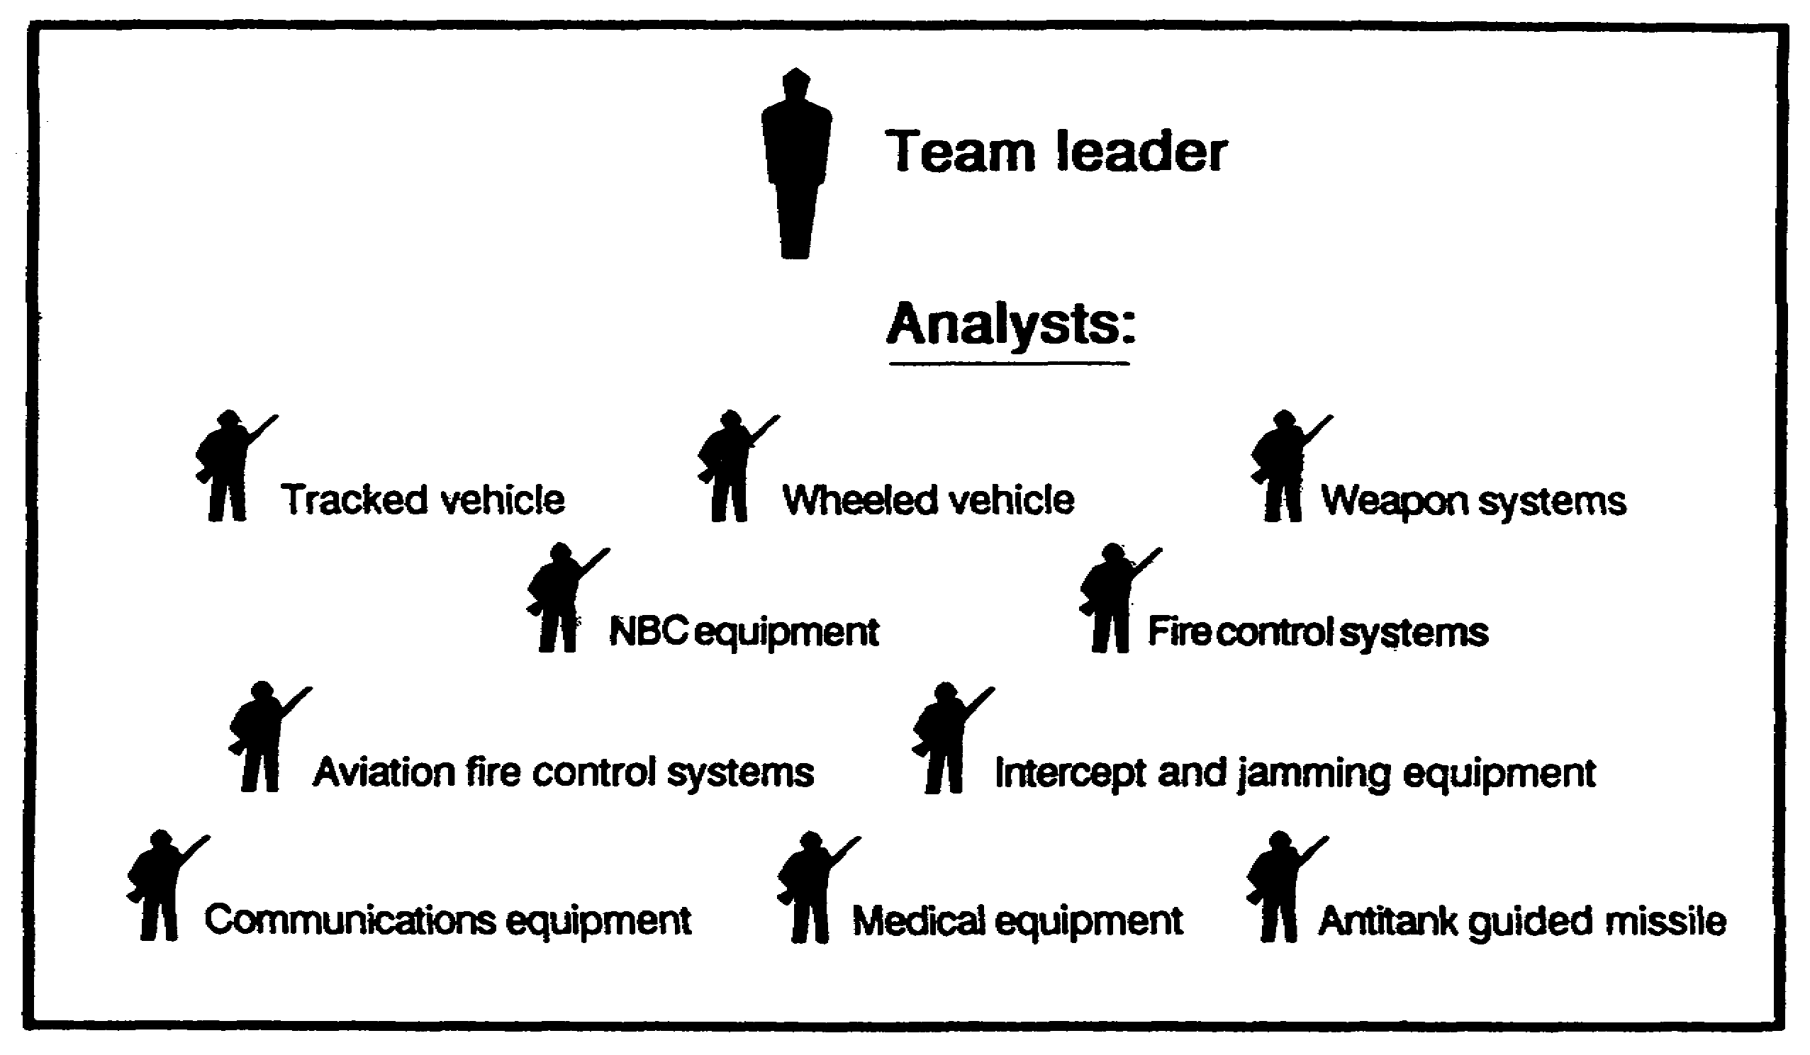

Figure 1-3. Battlefield TECHINT Team composition.

1-9 IT 0425

LESSON 1

PRACTICE EXERCISE

The following material will test your grasp of the material covered in this lesson. There is only one correct answer for each item. When you have completed the exercise, check your answers with the answer key that follows. If you answer any item incorrectly, study again that part of the lesson which contains the portion involved.

1. What is the mission of US Army elements producing TECHINT?

A. Collect information.

B. Analyze foreign materiel.

C. Support strategic echelon decision makers.

D. Support the tactical commander.

2. What is the formal organization of TECHINT?

A. Individual and DOD.

B. S&TI and battlefield TECHINT.

C. Individual and commander.

D. DIA and AIA.

3. Which Army major command is responsible for peacetime TECHINT?

A. DOD.

B. DIA.

C. INSCOM.

D. EAC TECHINT.

4. What is the responsibility of the CMEC?

A. Support the joint task force command.

B. Update data bases and requests for intelligence information.

C. Manage battlefield TECHINT and coordinate required support.

D. Direct, overall combined TECHINT effort under the supervision of intelligence staff.

IT 0425 1-10

5. Who serves as the point of contact for strategic S&TI activities on the battlefield?

A. CMEC.

B. Corps Support Command (COSCOM).

C. TECHINT section.

D. EAC TECHINT.

1-11 IT 0425

LESSON 1

PRACTICE EXERCISE

ANSWER KEY AND FEEDBACK

Item Correct Answer and Feedback

1. D. The mission of US Army elements producing technical intelligence is to support the tactical commander's effort to fight and win the Battle (page 1-3, para 3).

2. B. The formal organization is divided into the following two "communities." The S&TI community focuses on the TECHINT requirements of strategic policy and decision makers. The Battlefield TECHINT community serves the commander's intelligence requirements at the operational level (page 1-3, para 5).

3. C. INSCOM is the Army major command responsible for peacetime TECHINT operations (page 1-6, para d).

4. C. The CMEC manages, through the MI Bde commander and the G2, the command's battlefield TECHINT and coordinates required support to the TECHINT effort (page 1-8, para (2)(a).

5. A. The CMEC, through the brigade commander, also serves as the point of contact for strategic S&TI activities on the battlefield (page 1-8, para (2)(b).

IT 0425 1-12

LESSON 2

BATTLEFIELD TECHNICAL INTELLIGENCE
RESPONSIBILITIES

CRITICAL TASKS: 301-337-1321
301-337-1324
301-337-1325
301-373-3160

OVERVIEW

TASK DESCRIPTION:

In this lesson you will learn the different elements involved in TECHINT and their responsibilities in the reporting, handling, and exploiting TECHINT materiels.

LEARNING OBJECTIVE:

ACTIONS: Describe the elements of TECHINT and their responsibilities in reporting, handling, and exploiting TECHINT materiel.

CONDITIONS: You will be given narrative information and illustrations from FM 34-54.

STANDARDS: You will describe the elements of TECHINT and explain their responsibilities in reporting, handling, and exploiting TECHINT materiel IAW FM 54-54.

REFERENCES: The material contained in this lesson was derived from the following reference:

FM 34-54.

INTRODUCTION

There are many individuals, units, and activities with battlefield TECHINT responsibilities. Before one can truly comprehend how the system works one must first understand the roles the different players have. In other words, who does what. This lesson describes them and their roles in reporting, handling, and exploiting technical intelligence items.

2-1 IT 0425

STAFF OFFICERS

1. ASSISTANT CHIEF OF STAFF, G1, PERSONNEL. The G1s involvement in TECHINT is a result of his or her primary staff responsibility for -

a. Enemy Prisoners of War (EPW) and their accountability, humane treatment, and welfare. EPW are a rich source of information, equipment, and documents that are of interest to TECHINT. (The provost marshal, who works for the G3, manages the military police (MP) who actually evacuate, feed, and guard EPW.)

b. The command surgeon who has captured medical supply disposition and medical intelligence responsibilities has a bearing on TECHINT from the medical aspect.

c. Identifying personnel for special duty as linguists and technical subject matter experts in support of the TECHINT effort.

2. ASSISTANT CHIEF OF STAFF, G2, INTELLIGENCE. The G2 has primary staff responsibility for all intelligence activities within the command. The G2's TECHINT responsibilities include -

a. Supervising TECHINT collection activities: including interrogation and exploitation of personnel and documents of TECHINT interest.

b. Supervising technical intelligence planning, directing, processing, and disseminating.

c. Supervising TECHINT related training.

d. Staff supervision over the CMEC or attached TECHINT teams.

e. Staff supervision over the TECHINT appendix to the Operations Order Intelligence Annex.

f. Coordinating with the G3 the taskings of combat units, MPs, NBC, Explosive Ordinance Disposal (EOD), and others to capture and evacuate captured enemy materiel (CEM).

g. Coordinating with the G5 to screen refugees and local nationals for TECHINT information.

IT 0425 2-2

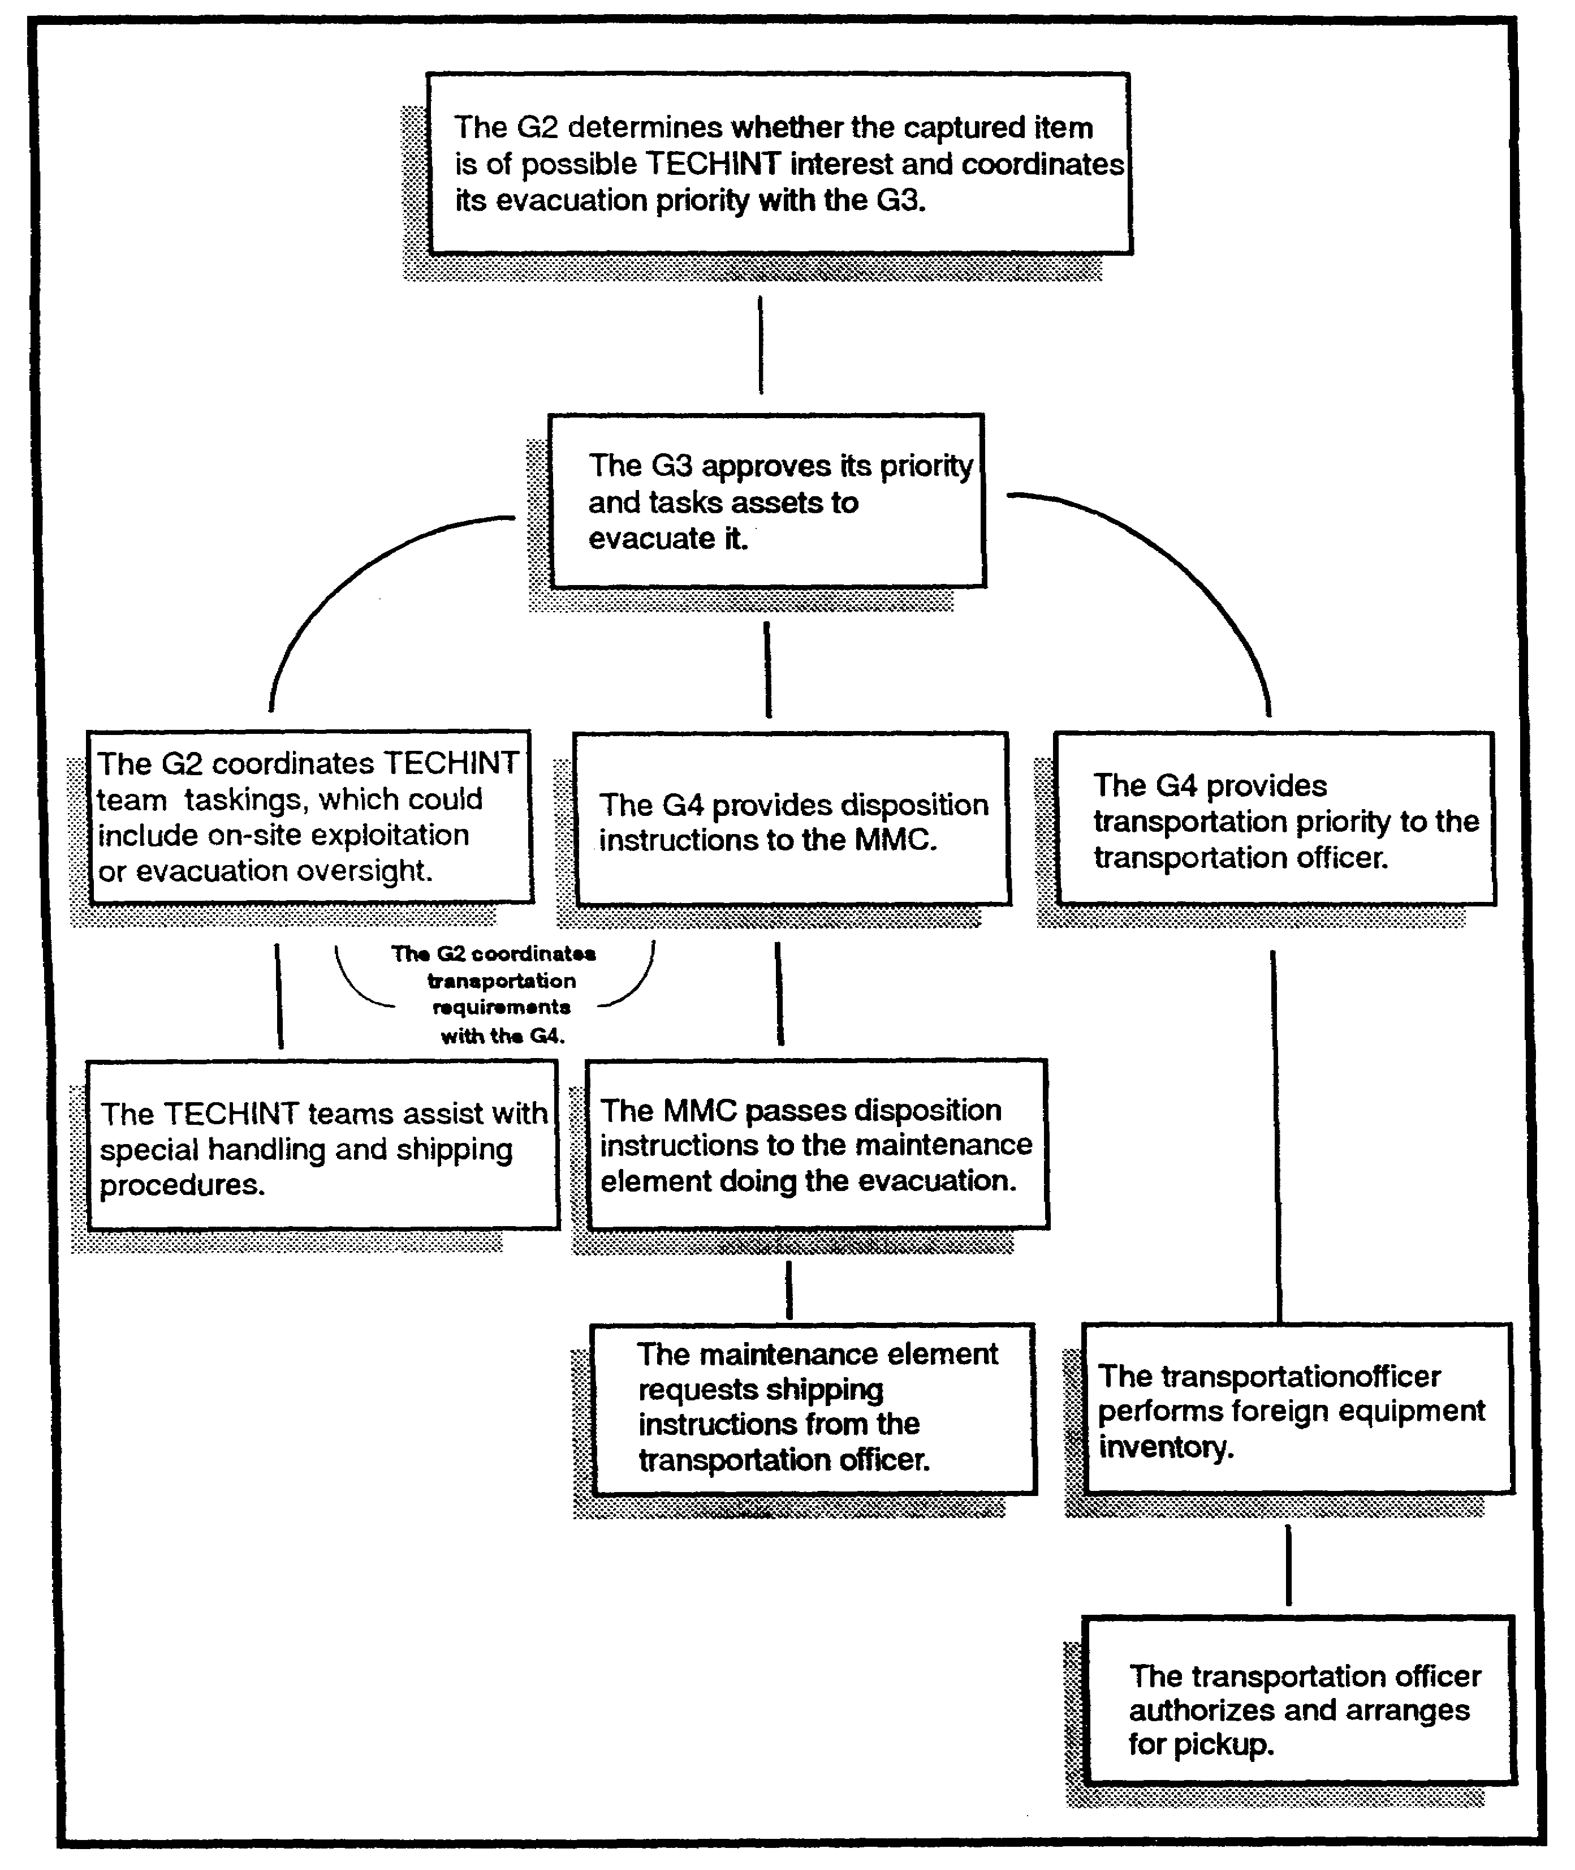

Figure 2-1. Flow of captured material guidance and decisions.

2-3 IT 0425

3. ASSISTANT CHIEF OF STAFF, G3, OPERATIONS. The G3 has overall staff responsibility for tasking subordinate elements, planning, organizing the force, and training. The G3s responsibilities as they relate to TECHINT includes:

a. Staff responsibility over several special staff officers that have specific TECHINT roles. They are the aviation officer, chemical officer, engineer officer, fire support coordinator, and the provost marshal (PM).

b. Staff responsibility for publishing the command's standing operating procedures (SOP) and operation plans and orders, which must address procedures for the handling and exploitation of CEM.

c. Staff responsibility for reviewing subordinate command SOP, plans, and orders to ensure CEM handling and exploitation procedures are included.

d. Assigning Battlefield TECHINT collection missions to subordinate elements of the command.

4. ASSISTANT CHIEF OF STAFF, G4, LOGISTICS. As the principal staff officer responsible for supply and transportation, the G4 has a vital TECHINT role. The G4s specific TECHINT coordination responsibilities include --

a. Staff responsibility over the EOD officer and the transportation officer whom have specific TECHINT related roles.

b. Coordinating with the G3 and the support command commander concerning transportation and storage support for Battlefield TECHINT collection operations.

c. Coordinating and developing command policy for the evacuation and reuse of captured materiel that is not thought to be of TECHINT interest.

d. Sets the main supply route which when reversed is also the primary evacuation route for the wounded, EPWs, and CEM.

e. Plans and coordinates construction of CMEC laboratory and operation facilities.

5. ASSISTANT CHIEF OF STAFF G5, CIVIL AFFAIRS. The G5 is the staff officer responsible for all matters concerning civilians and their impact on military operations. The G5s TECHINT responsibilities come about mainly as a result of civil affair (CA) and liaison responsibilities. The G5s responsibilities include -

a. Identifying local civilians who might have knowledge or interest to TECHINT analysts. These include: scientist, technicians, certain civil government employees and educators.

b. Notifying Battlefield TECHINT elements of the capture of TECHINT related equipment and documents discovered during routine to civil affair operations.

IT 0425 2-4

SPECIAL STAFF OFFICERS

1. Within the commanders staff are special staff officers with specific responsibilities that cover a broad range of activities on the battlefield. The following listing includes only those which provide coordinating support to the TECHINT effort or use TECHINT countermeasures.

a. THE AVIATION OFFICER will coordinate air evacuation of high priority TECHINT related equipment, documents, or personnel, usually back to CONUS.

b. THE CHEMICAL OFFICER coordinates requests for chemical troop employment in support of the CMEC, a Battlefield TECHINT team, or medical intelligence team on the battlefield.

c. THE ENGINEER OFFICER uses countermeasures from the CMEC on enemy weapon systems to improve and build more effective armor and infantry obstacles. The engineer officer is also responsible for coordinating requests for facility construction support to the CMEC.

d. THE EXPLOSIVE ORDNANCE DISPOSAL OFFICER exercises operational control over all EOD units. EOD personnel often work hard in hand with Battlefield TECHINT teams to render captured equipment safe from booby traps. They also frequently discover items of interest to TECHINT while doing EOD across the battlefield.

e. THE PROVOST MARSHAL is responsible for planning and supervising MP activities throughout the command. Regarding TECHINT this includes planning and supervising the following -

(1) Security for CMEC facilities, an evacuation of CEM, and designated personnel.

(2) Evacuating EPW and any documents and personal equipment associated with an EPW to internment and interrogation facilities.

(3) Procedures ensuring that MP identify, confiscate, report, and turn over to Ml personnel items of intelligence interest.

2. COMMANDER, MI BATTALION (TECHINT) is the senior TECHINT officer within the command, whether it be an all army, joint or combined command. He is also the director of the CMEC in whatever form it takes. He is personally responsible for managing TECHINT analyst operations in the CMEC and for advising the G2 and the Commander on all matters concerning TECHINT within the area of operations. He task organizes teams of experts for deployment in support of TECHINT operations throughout the area of operations. He assigns a TECHINT single discipline team (SDT) to the EACIC to manage TECHINT tasks within that center.

2-5 IT 0425

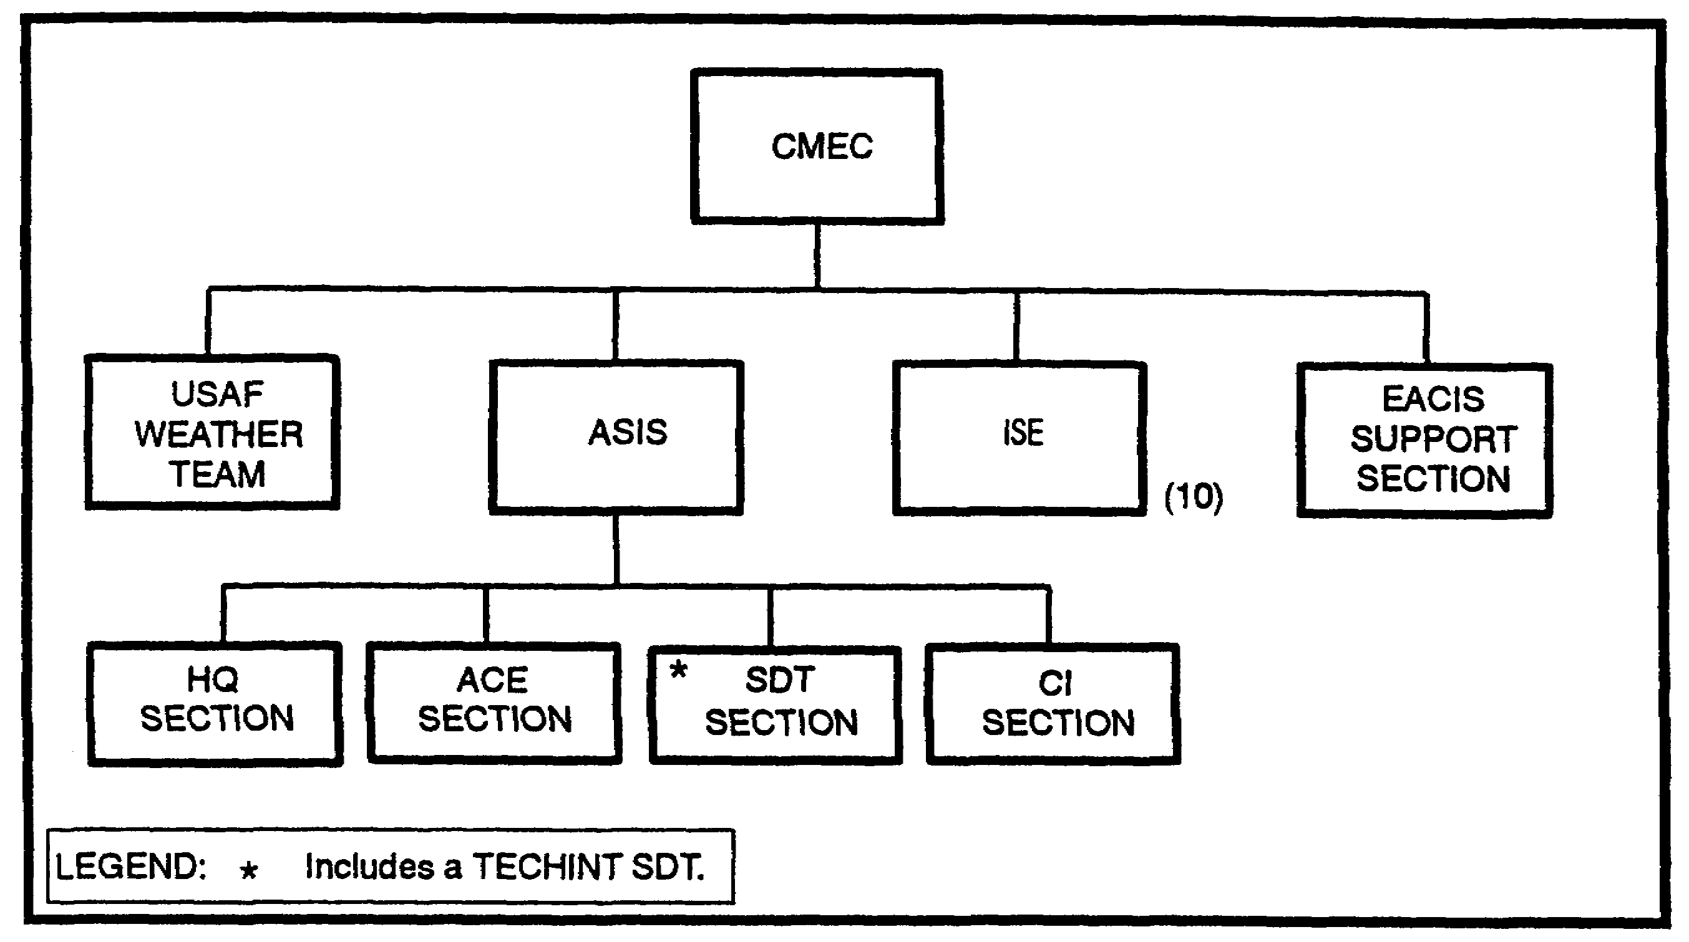

Figure 2-2. Echelons Above Corps Intelligence Center (EACIC).

3. THE COMMAND SURGEON has specific responsibilities in the collection and use of technical intelligence information. The command surgeon uses CMEC analyses and countermeasures to overcome any enemy use of NBC. He also recommends medically related intelligence collection requirements to the G2 and performs medical intelligence collection and reporting as required.

UNITS AND ORGANIZATIONS

This section talks about units and organizations with a TECHINT role. They may have been discussed in the previous two sections of this lesson.

1. CAPTURED MATERIAL EXPLOITATION CENTER (CMEC). The CMEC is the activity that analyzes and processes TECHINT related combat information into technical intelligence.

a. The goal is to give the combat commander tools that he can use to counter any advantage an enemy's weapon system or other equipment might have.

b. Using enemy armor as an example, it could begin with finding the weak spot on an enemy tank that our weapons can penetrate or designing a heavier anti-tank gun. It can be more complex, as in a tactic, such as engaging enemy tanks from buildings or trees since they have little top armor. These tools are called countermeasures. Countermeasures are why Battlefield TECHINT exists.

c. The TECHINT battalion commander forms the CMEC from his battalions assets. When the commander has augmentation from other services the center becomes a joint operation and is called a JCMEC. When augmented by other nations and allies the CMEC becomes a

IT 0425 2-6

combined operation and is called a CCMEC. Regardless of augmentation the center's job remains the same. The CMEC -

(1) Exploits captured enemy equipment (CEE) and technical documents.

(2) Analyzes friendly weapon systems damaged in battle.

(3) Reports findings and recommends countermeasures.

(4) Gives safety instructions to units discovering munitions.

(5) Coordinates with EOD.

(6) Coordinates with MP, Transportation, CA, Medical, Interrogators, and other elements to identify, screen, handle, and arrange evacuation of personnel and items of CMEC interest.

(7) Gives disposition instructions to combat units spot reporting the capture of CEM they think are of interest to the CMEC.

(8) Coordinates with the G2s collection management and dissemination section to incorporate TECHINT requirements into the priority intelligence requirements and information requirements (PIR/IR) development process.

2-7 IT 0425

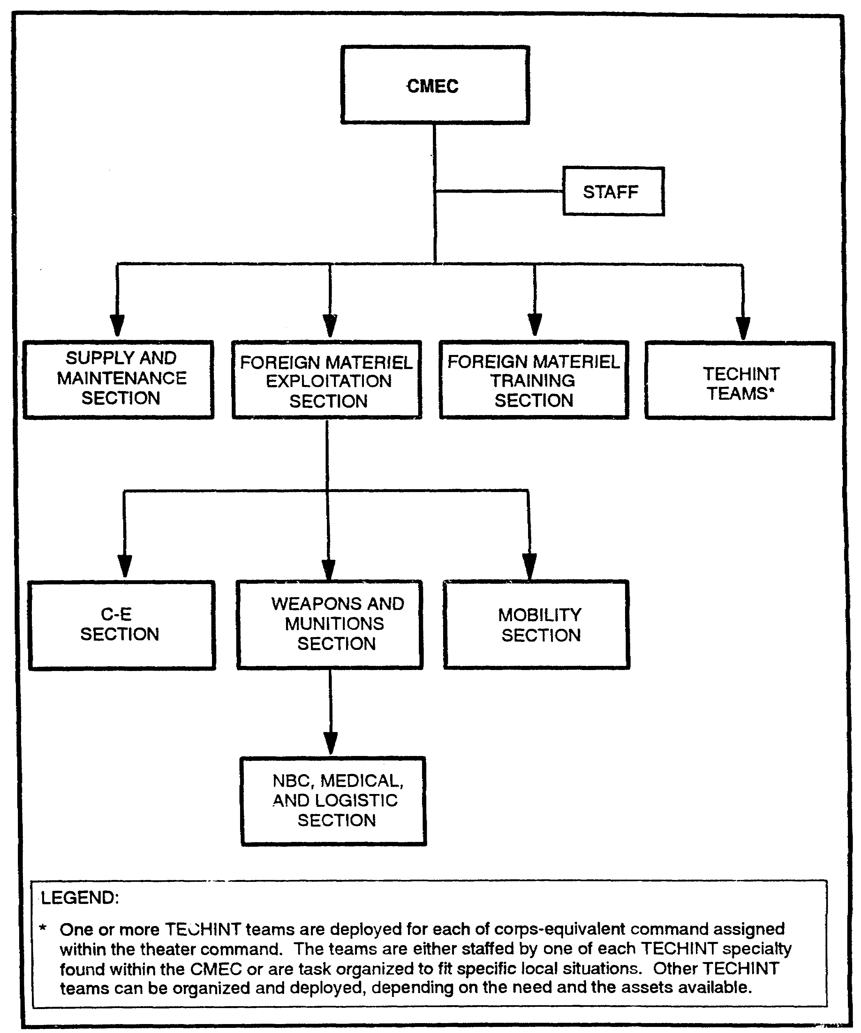

Figure 2-3. CMEC organization.

IT 0425 2-8

2. THE CAPTURING UNIT. Any unit on the battlefield could capture or discover items of interest to the CMEC. Therefore, all units must make provisions for handling captured equipment just as they must do to prepare for handling surrendering enemy soldiers. Some units, however, are more likely to encounter TECHINT type items than others. They include infantry, cavalry, engineers, NBC teams, EOD elements, MP, CA, and MI.

3. MI UNITS deserve special mention because their subelements while conducting routine operations are likely to either discover CEM or be asked to "please handle this for me".

a. Interrogation elements are the most likely to encounter CEM. Doctrinally, interrogators are collocated at brigade and division EPW collection points and at corps and theater EPW prison camps. They may even be attached as low as battalion or combat team and collocated with the HQ element. Interrogators have the responsibility for exploiting documents and personnel to try to answer the commander's PIR/IR. This job includes spotting CEM and EPW of TECHINT interest and then notifying the CMEC of the discovery.

b. All Ml units must have procedures, not just for interrogators but for all of their often widely dispersed subelements, to handle CEM they may come across. Some of these subelements likely to discover CEM or information of interest to the CMEC are --

- unmanned aerial vehicle operations

- counterintelligence activities

- electronic warfare operations

- imagery collection operations.

4. SPECIAL OPERATIONS FORCES (SOF) can play a vital role in collecting information and materiel of interest to the command's TECHINT effort. SOF is also a heavy user of TECHINT information and countermeasures when planning and executing missions. SOF isn't just special forces (SF) but also includes all Rangers, CA, and psychological operations (PSYOP) units.

a. SF and Ranger units, often operating deep in enemy territory, are usually the first to discover TECHINT related equipment, documents, weapons, and facilities. TECHINT related equipment, documents, weapons, and facilities. SF and Ranger units also have the capability to go behind enemy lines and find a wanted item, capture it, and get it back to the CMEC for analysis.

b. PSYOP units, have traditionally used tricks, ruses and ploys to acquire TECHINT related enemy materiel of interest to the commander. Examples range from giving bounties for the capture of jet aircraft in Korea to rifles in more recent conflicts.

c. Civil Affairs units, play a vital part in TECHINT collection operations. This is mainly because of their refugee handling and local national liaison role.

2-9 IT 0425

(1) CA identifies civilian equipment, documents, and personnel of interest to the commander's TECHINT effort.

(2) CA also has many scientific and technical specialists that can help the CMEC as subject matter experts. CA personnel include experts in such areas as food and agriculture; public communications, health, transportation, and supply; public works and utilities; and areas of commerce and industry.

(3) CA hires civilian technicians, scientists, professionals, skilled craftsmen, and laborers as necessary to support the TECHINT effort.

5. ENGINEER TOPOGRAPHIC AND TERRAIN UNIT. These units are responsible for collecting, evaluating, and disseminating topographic information and terrain intelligence. They normally function at theater, corps, and division levels. The CMEC uses engineer topographic and terrain products to support TECHINT collection planning. Engineers can also serve as subject matter experts in their specialist areas.

6. MILITARY POLICE UNIT (MP) are in a unique position to assist TECHINT related operations. They often confiscate and identify foreign materiel and documents from EPW of interest to the TECHINT effort. If not done previously, MP mark end or tag all enemy equipment and personnel in their custody. Accurate identification on the capture tag helps TECHINT analysts and interrogators match materiel with EWP to assist in interrogation.

7. NUCLEAR, BIOLOGICAL, AND CHEMICAL RECONNAISSANCE TEAM provide an important service in support of contaminate collection of extreme interest to the TECHINT effort. The command surgeon, staff NBC officer and the staff intelligence officer coordinate with NBC teams to collect, identify, and evacuate suspected samples of nuclear materials and biological and chemical warfare agents.

The CMEC uses information collected to develop tactics and protective countermeasures against the enemy's NBC threat.

8. MEDICAL UNIT. Ml elements (TECHINT teams, CMEC, intelligence staff officers at the operational and tactical level) may request specialized medical or medical intelligence assistance from combat zone or communication zone (COMMZ) health service support assets. Plans, operations, and intelligence sections of medical command and control headquarters (medical command, medical brigade, and medical group) coordinates this assistance to Ml units. Some examples of the types of assistance medical headquarters can provide, are as shown in Figure 2-4.

IT 0425 2-10

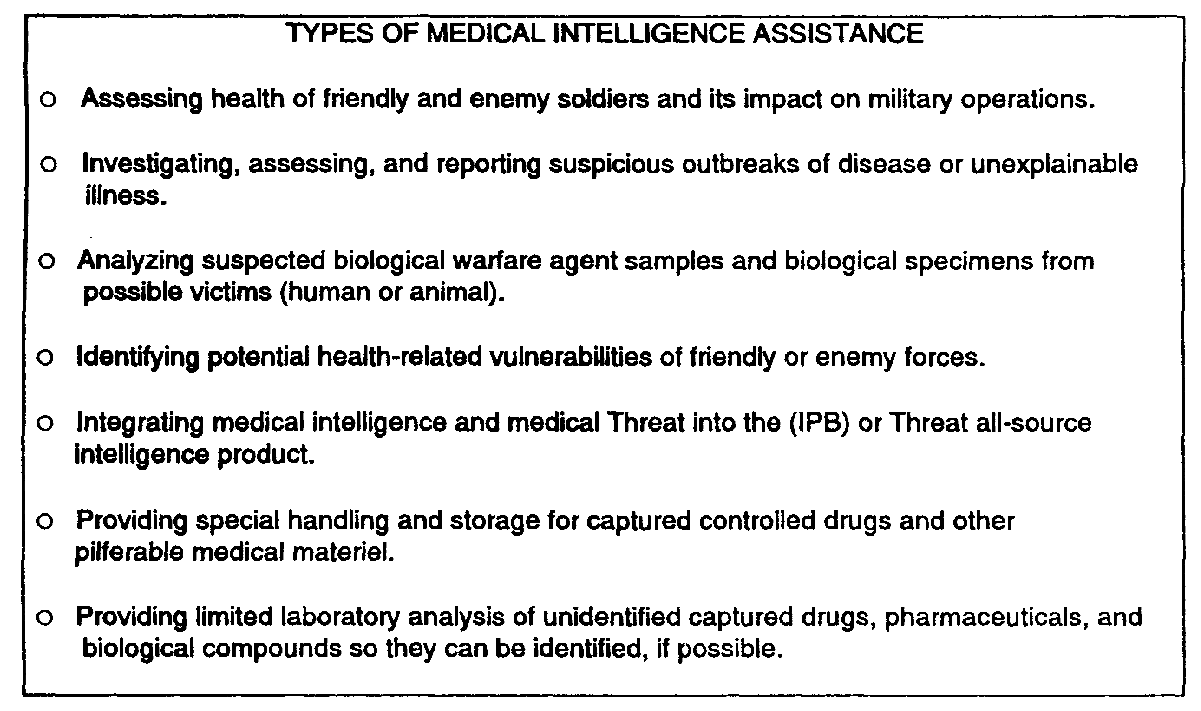

Figure 2-4. Types of Medical Intelligence Support Available on the Battlefield.

9. EXPLOSIVE ORDINANCE DISPOSAL UNIT. One of the most critical yet deadly sources of TECHINT on the battlefield is explosive ordnance. To safely exploit this source, explosive ordnance disposal (EOD) units provide specially trained personnel to support TECHINT elements in the area of operations, as shown in Figure 2-5.

EOD personnel examine existing reports and prepare TECHINT reports on unusual items of explosive ordnance discovered during disposal operations. TECHINT personnel coordinate closely with EOD personnel for proper disposal and evacuation of explosive ordnance. EOD PERSONNEL DO THE ACTUAL HANDLING OF EXPLOSIVE ORDNANCE. EOD units report TECHINT information to the CMEC.

2-11 IT 0425

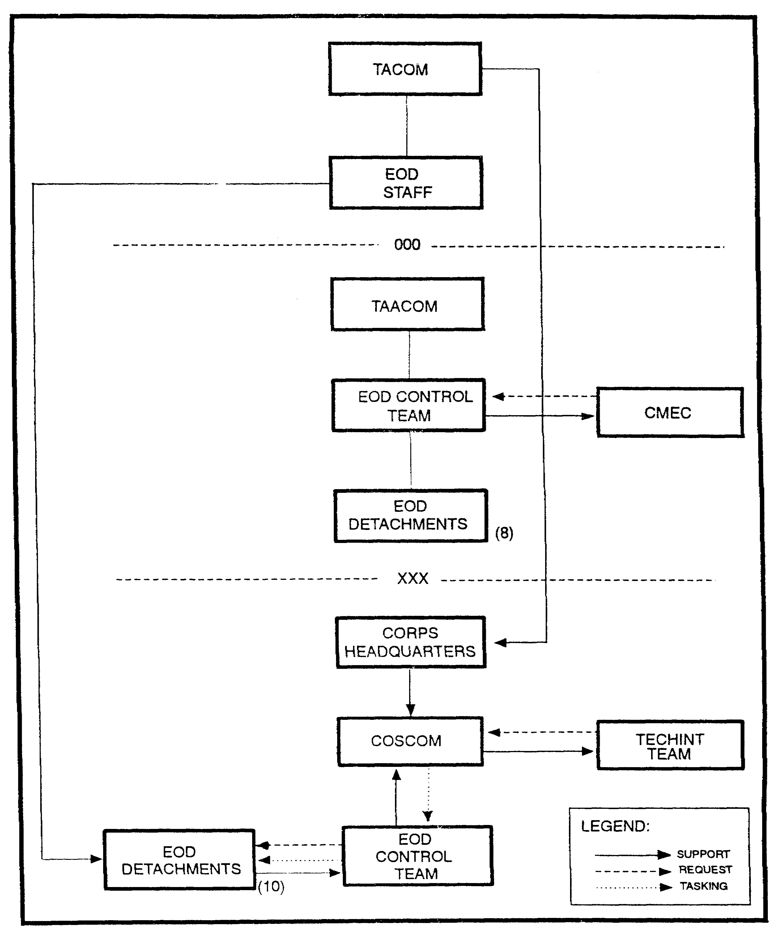

Figure 2-5. Explosive ordnance disposal (EOD) support to TECHINT.

IT 0425 2-12

LESSON 2

PRACTICE EXERCISE

The following material will test your grasp of the material covered in this lesson. There is only one correct answer for each item. When you have completed the exercise, check your answers with the answer key that follows. If you answer any item incorrectly, study again that part of the lesson which contains the portion involved.

SECTION/UNIT/ORGANIZATION RESPONSIBLE FOR:

1. G1 A. Assign battlefield TECHINT collection missions.

2. G2 B. Often confiscate and Identify foreign materiel and documents from EPW.

3. G3 C. Identify local civilians who might have knowledge of interest to TECHINT analysts.

4. G4 D. EPW, their accountability, humane treatment and welfare.

5. G5 E. Analyzes and processes TECHINT related combat information into technical intelligence.

6. Engineer Officer F. Uses countermeasures from the CMEC on enemy weapons systems.

7. MP Unit G. Supervise TECHINT related training.

8. CMEC H. Coordinate with transportation and storage for battlefield collection operations.

2-13 IT 0425

LESSON 2

PRACTICE EXERCISE

ANSWER KEY AND FEEDBACK

Item Correct Answer and Feedback

1. D. The GI has primary staff responsibility for enemy prisoners of war and their accountability, humane treatment, and welfare (page 2-2, para 2).

2. G. The G2s TECHINT responsibilities include supervising TECHINT related training (page 2-2, para 8).

3. A. The G3s responsibilities as they relate to TECHINT include assigning battlefield TECHINT collection missions to subordinate elements of the command (page 2-4, para 5).

4. H. The G4s specific TECHINT coordination responsibilities include coordinating with the G3 and the support commander concerning transportation and storage support for battlefield TECHINT collection operations (page 2-4, para 8).

5. C. The G5s responsibilities include identifying local civilians who might have knowledge of interest to TECHINT analysis (page 2-4, para 13).

6. F. The engineer officer uses countermeasures from the CMEC on enemy weapon systems to improve and build more effective armor and infantry obstacles (page 2-5, para 5).

7. B. Military police units often confiscate and identify foreign materiel and documents from EPW of interest to the TECHINT interest (page 2-5, para 10).

8. E. The CMEC is the activity that analyzes and processes TECHINT related combat information into technical intelligence (page 2-6, para 3).

IT 0425 2-14

LESSON 3

BATTLEFIELD TECHNICAL INTELLIGENCE

CRITICAL TASKS: 301-337-1321
301-337-1324
301-337-1325
301-373-3160

OVERVIEW

TASK DESCRIPTION:

In this lesson you will learn the objectives of TECHINT, reporting and tagging of captured equipment, TECHINT references and TECHINT reports.

LEARNING OBJECTIVE:

ACTIONS: Describe the objectives of TECHINT, how to report and tag captured equipment, and know TECHINT references and reports.

CONDITIONS: You will be given narrative information and illustrations from FM 34-54.

STANDARDS: You will describe the objectives of TECHINT, know how to report and tag captured equipment and know the TECHINT references and reports.

REFERENCES: The material contained in this lesson was derived from the following reference:

FM 34-54.

INTRODUCTION

Our nation can no longer rely solely on sheer weight of manpower or mass production capabilities to ensure national security. Our future security depends upon our ability to consistently maintain technological superiority over present or potential enemies. TECHINT plays a very important role in maintaining technological superiority. Before you can determine whether your country holds a supreme position in any given area of technology, you must know the current positions and future plans of the other nations.

NOTE: Foreign technological capabilities must be determined to avoid technological surprise, since failure to gather this information is often the cause of defeat or annihilation.

3-1 IT 0425

BATTLEFIELD TECHINT BASIC OBJECTIVES.

For TECHINT to contribute meaningfully to the overall intelligence effort, it should satisfy at least one of the following basic objectives (subject to the requirements of the situation):

- Determination of foreign technological capabilities.

- Development of countermeasures.

- Exploitation of new ideas.

- Use of foreign equipment.

1. Countertactics and Counterweapons. Whenever a new weapon or procedure is introduced on the battlefield, it becomes necessary to counter its effect by creating a new weapon, by devising some sort of protection, or by developing a new tactic. When information can be gathered on new weapons or procedures before their employment on the battlefield, then countertactics and counterweapons can be developed or instituted before these new weapons or procedures appear.

- British Antitank Gun. The development of the British 17-pounder anti-tank gun is an example of a counterweapon developed because of efficient TECHINT. In 1942, British Intelligence began receiving reports of a new German tank under development. Throughout the year, these reports filtered in from covert sources until, near the end of the year, enough information was accumulated to present an accurate picture of a German Mark V "Panther" tank. A counterweapon, the British 17-pounder anti-tank gun, was designed, developed, and placed into production. The first 17-pounder was delivered to the troops 3 weeks before the appearance of the "Panther" tank on the Western Front. The allies not only filled a potential firepower gap but also reaped a psychological coup.

2. Captured Enemy Materiel. Learning the capabilities, limitations and vulnerabilities of foreign equipment is one of the objectives of TECHINT. To accomplish this objective, detailed information on the enemy's equipment must be obtained and distributed. Information must be placed in the hands of the troops in close contact with the enemy, so that they may become familiar with the enemy's equipment.

a. Information on Enemy Weapons and Equipment. Effective use of enemy weapons and equipment is dependent upon educating the troops and persuading them to use initiative in applying the materiel in tactical situations. TECHINT personnel prepare manuals, charts, and diagrams on enemy weapons and equipment, carefully detailing the nomenclature, operations, and functions.

b. Evacuation of CEM is the responsibility of the echelon commander wanting the item. It is up to the TECHINT element at that echelon to coordinate the staff actions

IT 0426 3-2

necessary to get the item to the unit. This does not mean that the TECHINT team will go and pick up the item, the team's job is only to help arrange it.

It is possible that the TECHINT team will want to go to the site and supervise packing, crating, and transportation for high priority items. But it is definitely not required since the team isn't equipped for handling routine evacuation of all CEM.

c. Every intelligence officer with a unit on the battlefield is required to include in the intelligence annex, plans for --

- How and where the report the capture of prisoners and documents of Ml value, and CEM of TECHINT value.

- Handling procedures to include security, and tagging.

- Evacuation procedures to include identifying collection points, transportation, and guards.

d. Capturing Unit Procedures. Capturing units discovering items either known from PIR/IR to be of interest to TECHINT or items that they "think" would be of interest to TECHINT or items that they "think" would be of interest to TECHINT have three tasks --

- Secure and Safeguard the item.

- Spot Report the item through higher headquarters to the first TECHINT element in the chain of command (usually corps or theater.)

- Tag the item and wait for further instructions from higher headquarters.

e. Other Capture Unit Tasks. The CMEC, through higher headquarters could request the capturing unit to do other tasks depending on the item. Some of these tasks might be to --

- Forward more complete descriptions of the items captured.

- Photograph or sketch the item.

- Ship to the next higher echelon.

- Send documents through EPW evacuation channels.

- Take a piece of equipment off the item and forward that.

- Notify EOD, NBC, or Medical unit.

- Standby for TECHINT team arrival.

3-3 IT 0425

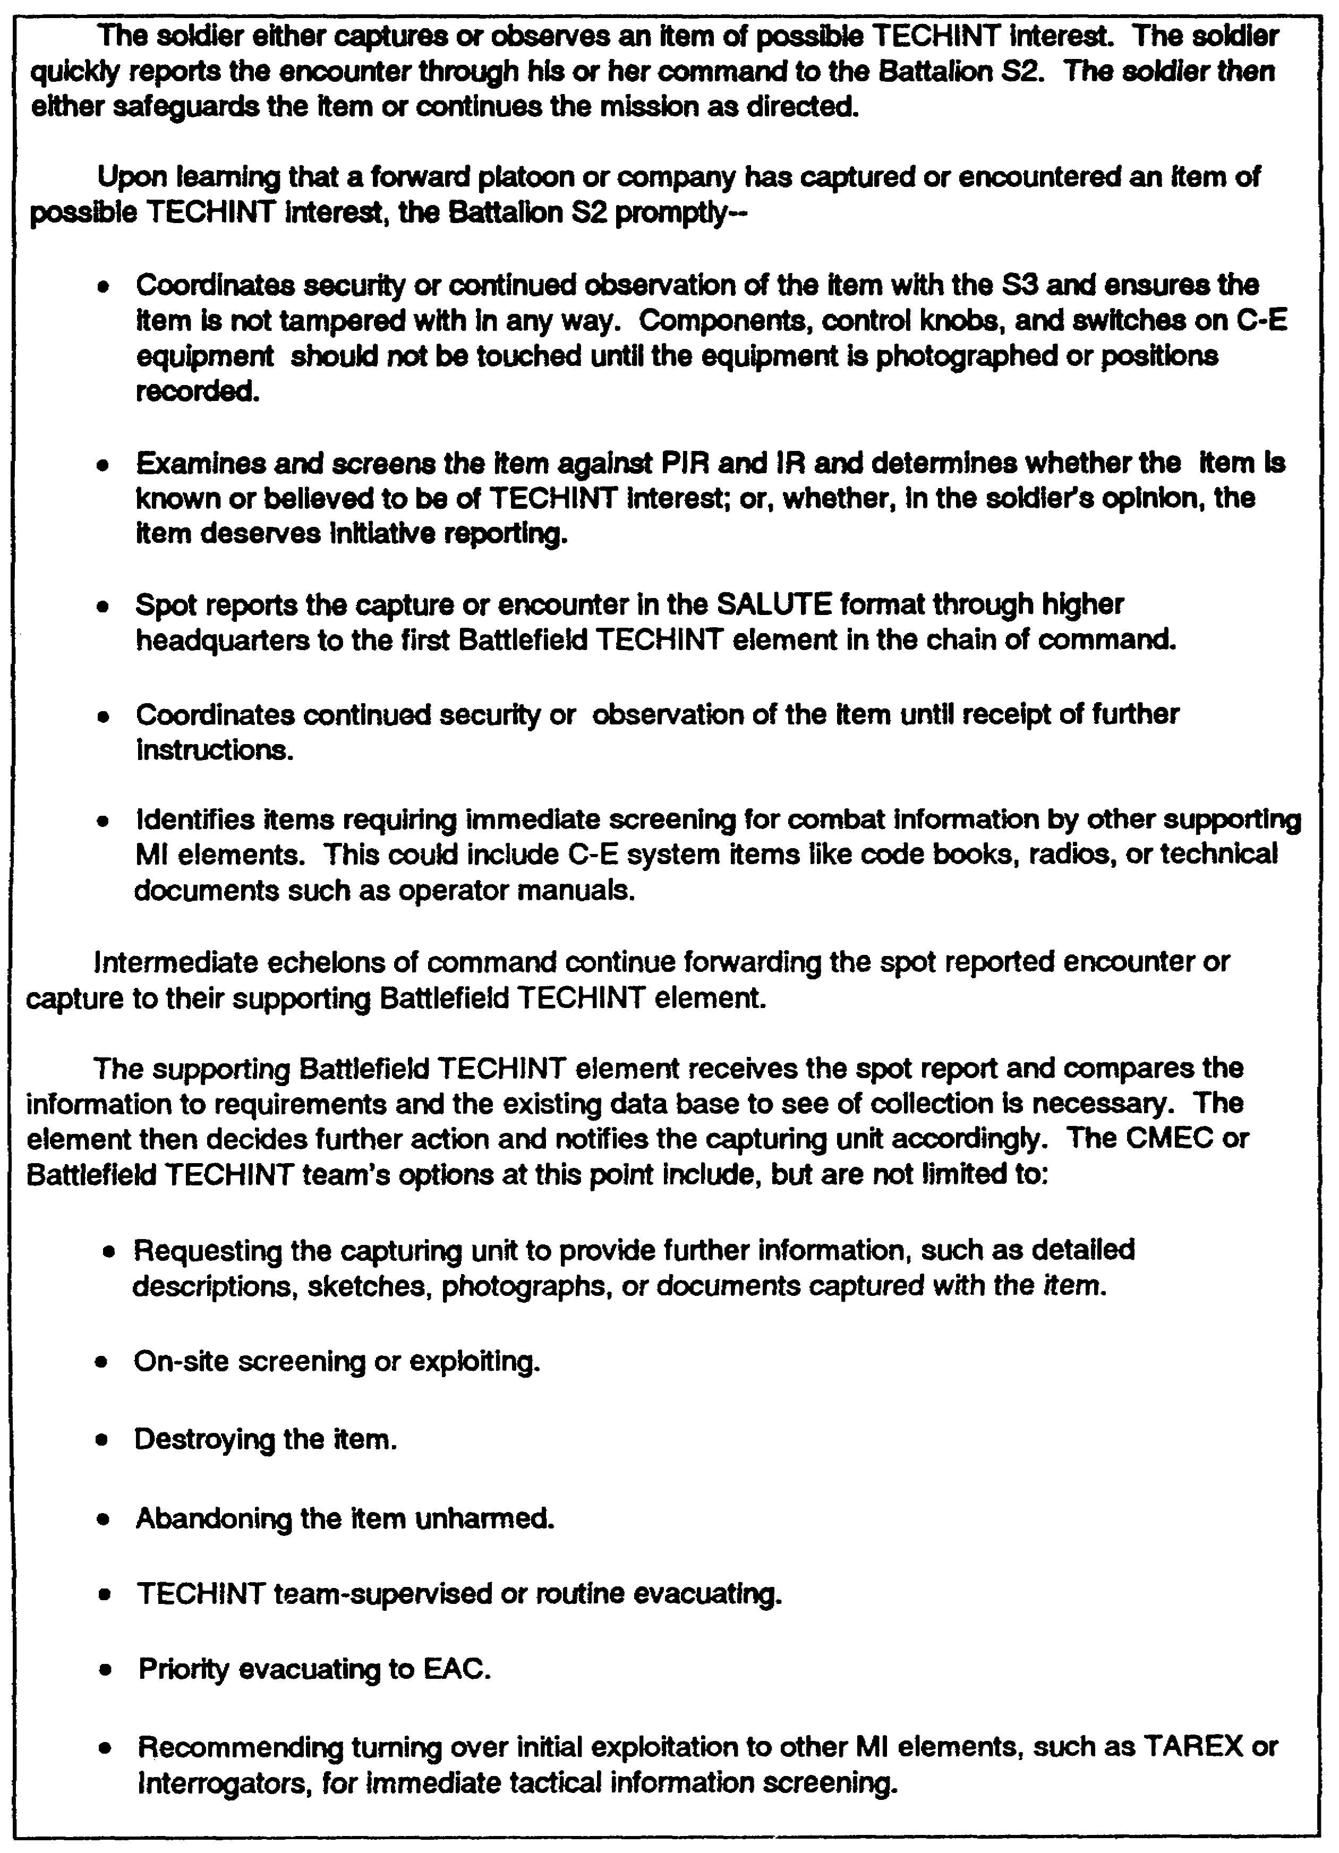

Figure 3-1. Sequence of Collection Events

IT 0425 3-4

- Abandon in place, leaving item unharmed. (As in the case of medical material).

- Destroy the item.

f. The key point to remember is that only CEM wanted by the CMEC or the corps TECHINT team are evacuated for TECHINT exploitation. This is why the use of the spot report in the SALUTE format is so important. The spot report is fast and brief. It doesn't clog communication channels, but it does give the TECHINT team all the information needed to see if they need to know more.

3. ON SITE ANALYSIS. The CMEC (or the corps TECHINT team) may determine to send a team for on site analysis.

a. The determination for on site analysis is based on a want list made up from the commander's PIR and IR and four other factors. They are --

(1) Nature of the item captured. This includes whether it can be safely moved or if it requires special handling and security.

(2) Time available. For instance, if it is of such high priority that experts need to analyze it now.

(3) Manpower available to the team.

(4) Other experts are available or better qualified. Examples could be EOD, interrogators, medical, intelligence, or engineers.

b. The TECHINT team seeks to obtain the following information during on site analysis --

(1) Equipment operational characteristics, performance capabilities, and vulnerabilities.

(2) identification of new significant weapons.

(3) Previously unknown modifications.

(4) Possible countermeasures.

(5) How to handle NBC contaminated items.

4. CAPTURE ELECTRONIC COMMUNICATIONS EQUIPMENT are of extreme interest to military intelligence. Exploitation of enemy signal's documents and equipment have often been the key to victory in war in recent history.

a. The capturing unit has no special provisions for handling and evacuation of cryptographic items and communications equipment. it is to safeguard and spot report

3-5 IT 0425

the item like any other item thought to be of TECHINT interest. Disposition instructions will follow.

b. Intelligence Officers and MI units do have special provisions. The provisions are set forth in unit SOP but always include notification of the closest Analysis and Control Element (ACE). ACEs are found at separate brigades, cavalry regiments, and headquarters echelons division and above. The ACE coordinates handling, evacuation, and exploitation procedures with the supporting TECHINT element.

c. Items of interest to the ACE and CMEC include -

- Secure voice equipment.

- Encryption devices.

- Related documents.

- Code and Key lists.

- Codes messages.

- Signal Operation Instructions (SOI).

- Disposition of enemy signal units and their radio vans.

5. DISPOSAL OF ENEMY MATERIEL. As stated before not all CEM is of interest to intelligence. yet, almost all CEM is of interest to the army in general.

a. The G4/S4 coordinate and establish procedures for the evacuation of such items through supply routes and collection points. The G4/S4 have the ultimate responsibility for final disposition of items but only after making sure that they are not needed by the CMEC, staff surgeon, civil affairs, and so on.

b. The CMEC double checks the TECHINT spot reporting process by sending TECHINT teams to visit the various logistic collection points. This team checks records, interviews collection point soldiers, and visually checks the area to spot items missed in previous collection efforts.

c. Final disposal of CEM is in accordance with SOP.

6. TAGGING EPW CAPTURED ENEMY DOCUMENTS AND EQUIPMENT. Tagging EPW, documents, and CEM is the responsibility of the capturing unit. S2s, MPs, interrogators, and TECHINT analysts must tag items not tagged by the capturing units. Tagging is necessary to help route the item through evacuation channels, maintain accountability, and to identify associated prisoners for interrogation.

a. The first rule in tagging is to tag items which don't have tags. Find out as much capture information as you can and fill out the tag as completely as possible.

IT 0425 3-6

b. The second rule is to protect the item from damage, soiling, weather, or wear. Do not unnecessarily touch the item, adjust dials, or mark on it in any way. Many units find ziplock plastic gags or shotgun envelopes ideal for protecting small items and documents.

c. Next, select the right tag. Use an EPW tag for documents and a TECHINT tag for equipment. If no prepared tag forms are handy, improvise. (See Figure 3-2).

d. Finally fill out the tag. If improvising always include as much of the following information as you know --

- When captured.

- Location of capture.

- Circumstances surrounding the capture.

- The capturing unit.

- Other documents, equipment, or EPW captured along with or near the item.

3-7 IT 0425

CAPTURED ENEMY EQUIPMENT TAG

This is an example of the front and reverse sides of a CEE tag. It is used as a tab to the TECHINTs Appendix to the Intelligence Annex of the Operations Plan or Operation Order.

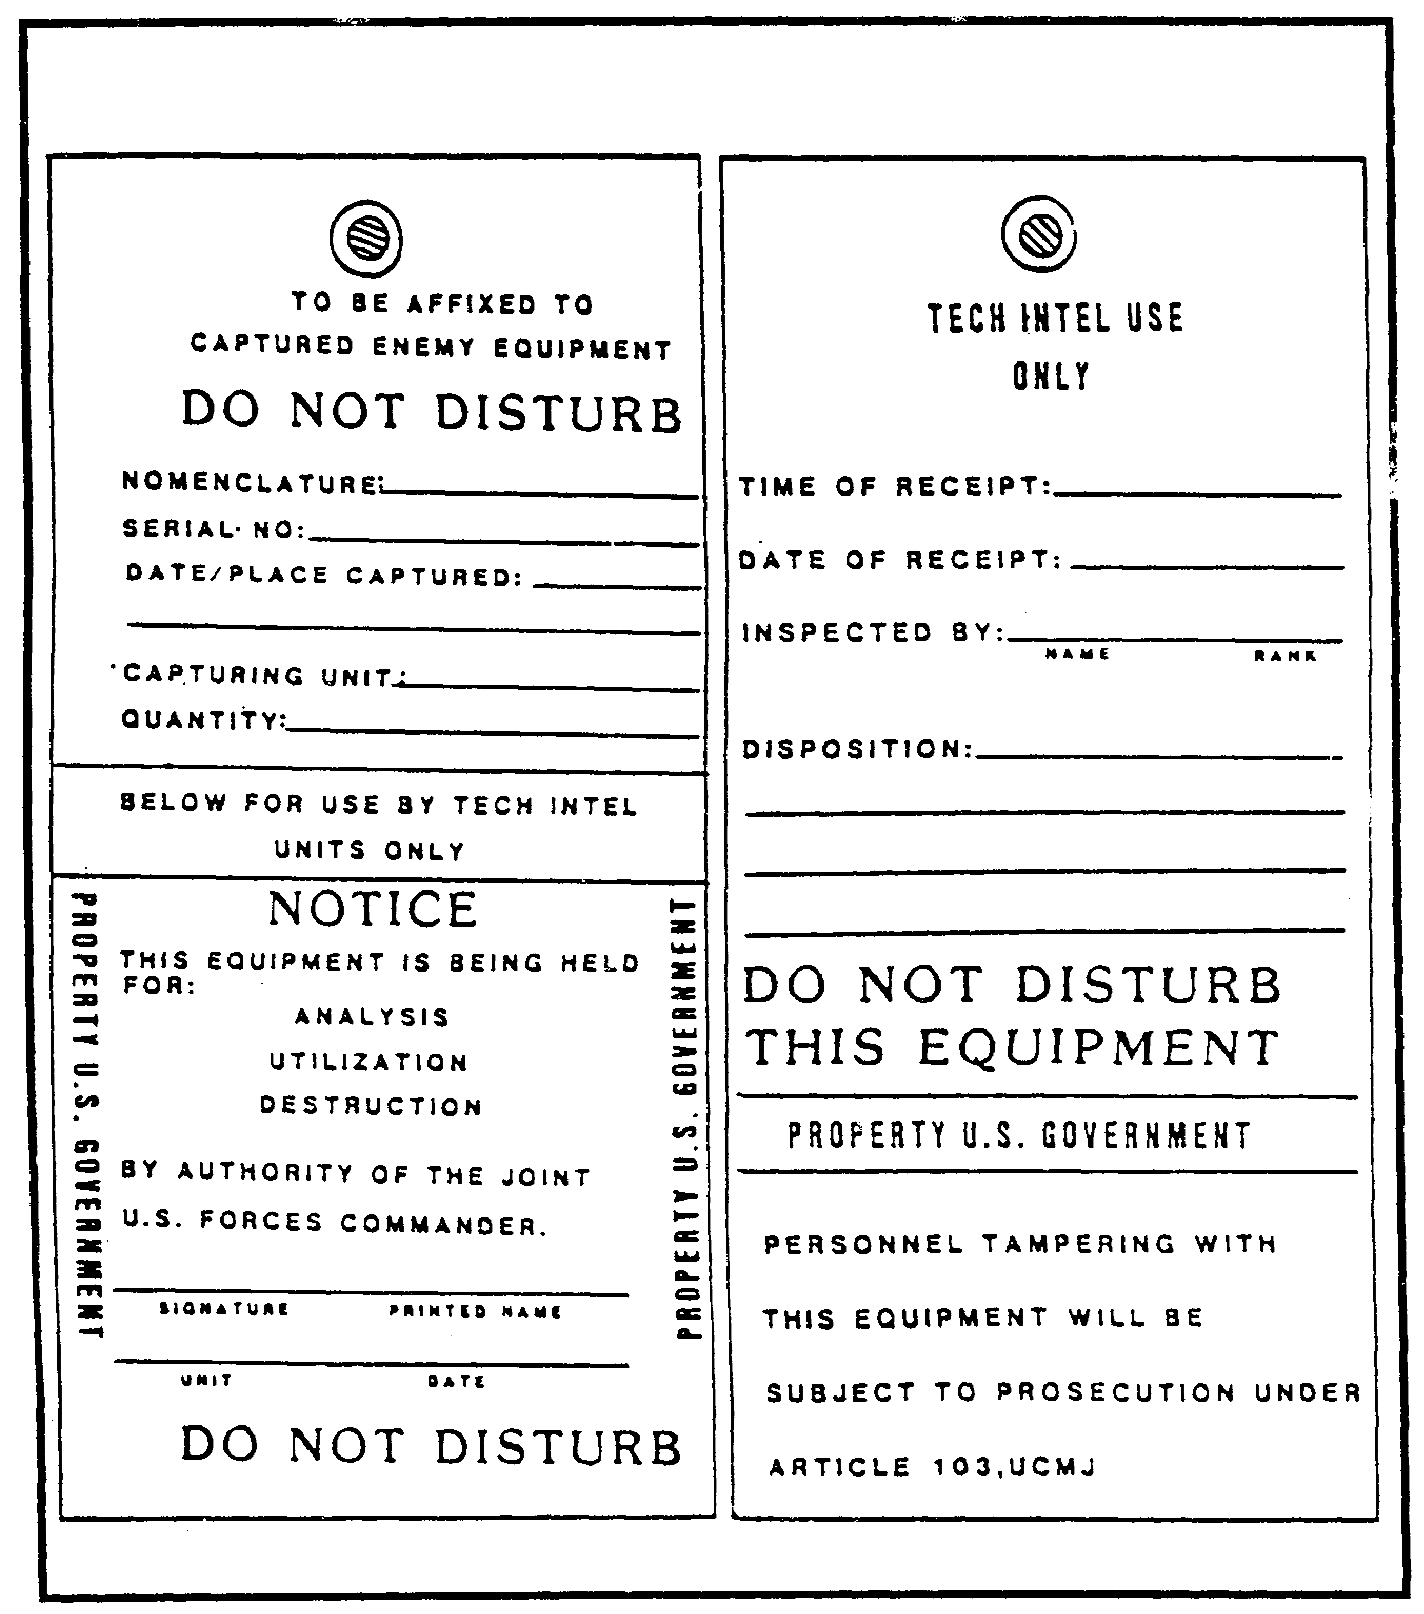
Figure 3-2. Front and Reverse Sides of Captured Enemy Equipment Tag.

IT 0425 3-8

PRISONER OF WAR CAPTURE TAG

This is an example of the front and reverse sides of a prisoner of war capture tag.

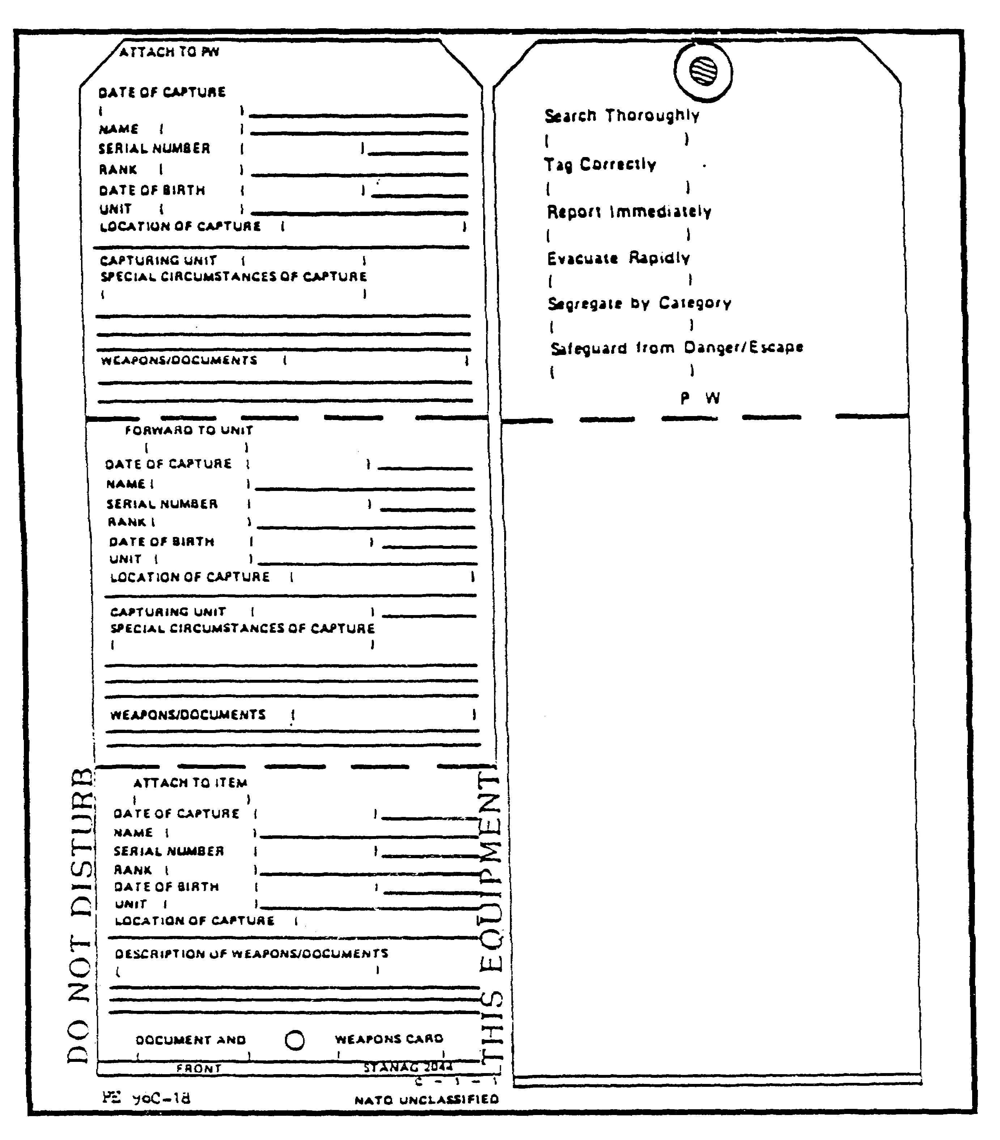

Figure 3-3. Front and Reverse Sides of a Prisoner of War Tag

3-9 IT 0425

7. DOCUMENTS AND EQUIPMENT FOUND ON AN EPW. The items EPW get to keep and what can be taken from an EPW is the purview of MPs and interrogators. However, TECHINT analysts should be familiar with the basic rules.

a. Some items captors may briefly examine but must give back to the EPW. The laws of land warfare specifically require that EPWs be allowed to keep all personal protective equipment as long as they are in a war zone. This includes helmets, flak vests, canteens, coats, boots, and so on. They also always get to keep their identification (ID) cards and personal correspondence items. The captor can search and examine these items. One can, under certain circumstances, confiscate these items, providing the danger has passed or the item is replaced.

b. What captors must impound. Impounded items still belong to the EPW but are being held for security reasons. The EPW always gets a receipt and no items may be impounded unless so ordered by a commissioned officer. Items normally impounded include money and valuables.

c. What captors may confiscate. Official documents, weapons, and military equipment (except identity cards and protective gear) are confiscated. They will not be returned to the EPW.

8. DOCUMENT EXPLOITATION. Interrogators have responsibility for selecting and examining documents for intelligence information. They spot report all information obtained that helps answer the supported combat commander's PIR/IR. They will also identify documents they believe are wanted by other intelligence specialists to include TECHINT analysts.

The CMEC keeps a TECHINT liaison team at EPW prison camps to verify TECHINT documents flagged by interrogators. The TECHINT team arranges immediate exploitation of the document or forwards it to the CMEC.

9. BATTLEFIELD TECHINT PRODUCTION. TECHINT information production requires reference library and data base facilities and the skills of technical analysis specialists.

a. TECHINT Reference Library. TECHINT production, research, analysis, and evaluation cannot be conducted without current information. The need for specific data requirements, performance characteristics, equipment descriptions, operational limitation of materiel, and the extensive need for integration and collation to technical information requires a current and up to date reference library. The library is one of the most useful working tools for the TECHINT elements.

- Library technical publications provide accurate and timely technical information and intelligence references. A library technical publications must be oriented toward the needs of combat, combat service support users, and EAC requirements. As a minimum, the technical library should include:

1 - Technical bulletins.

2 - Foreign equipment handbooks (by country).

IT 0425 3-10

3 - Catalogs of foreign materiel.

4 - DIA scientific and technical intelligence registers.

5 - Organizational and logistical data handbooks.

6 - Enemy tables of organization and equipment (TOE).

7 - Appraisals of enemy equipment.

8 - Equipment vulnerability studies.

9 - Enemy studies and assessments.

b. Specialized Technical Analysis. The TECHINT will sometimes require outside assistance from military or civilian specialists or organizations in the technical analysis of materiel or special technical and strategic missions. Individuals whose training could be helpful include:

1 - Ammunition maintenance technicians.

2 - Guided missile maintenance personnel.

3 - Nuclear weapons specialists.

4 - Guided missile and special weapons personnel.

5 - Ammunition supply specialists.

6 - Data processing personnel.

7 - Electronic countermeasures personnel.

8 - Cryptographic personnel.

9 - Communications security analysts.

10 - Optical and explosive ordnance specialists.

11 - Petroleum product analysts.

12 - Guided missile propellant and explosives specialists.

13 - Communications and radar specialists.

14 - Medical, chemical, physics, and biological personnel.

3-11 IT 0425

10. TECHNICAL INTELLIGENCE REPORTS.

Six types of TECHINT reports are generally used:

1 - Spot Report (SPOTREP) in SALUTE format.

2 - Preliminary Technical Report (PRETECHREP).

3 - Complementary Technical Report (COMTECREP).

4 - Detailed Technical Report (DETECHREP).

5 - Technical Document Report (TECHDOCREP).

6 - Special Technical Report.

a. Standardization Agreements (STANAG). STANAG 2084 is the agreement on handling and reporting of captured enemy equipment and documents. STANAG 2097 is an outline of current North Atlantic Treaty Organization (NATO) standardized nomenclature. When possible, all TECHINT reports nomenclature should be NATO-standardized.

b. SPOTREP. This is an oral or written report which is prepared by the capturing unit and/or intermediate command echelon for rapid reporting (electrical or other means) of the acquisition of captured or abandoned foreign materiel through their next higher headquarters to the TECHINT element. The basic items of this report should include as a minimum:

1 - Size or quantity of the item.

2 - Activity reported or item captured.

3 - Location of the item.

4 - Unit or nationality of the item.

5 - Time of report.

6 - Equipment: The items description and other items or personnel captured at the same time.

IT 0425 3-12

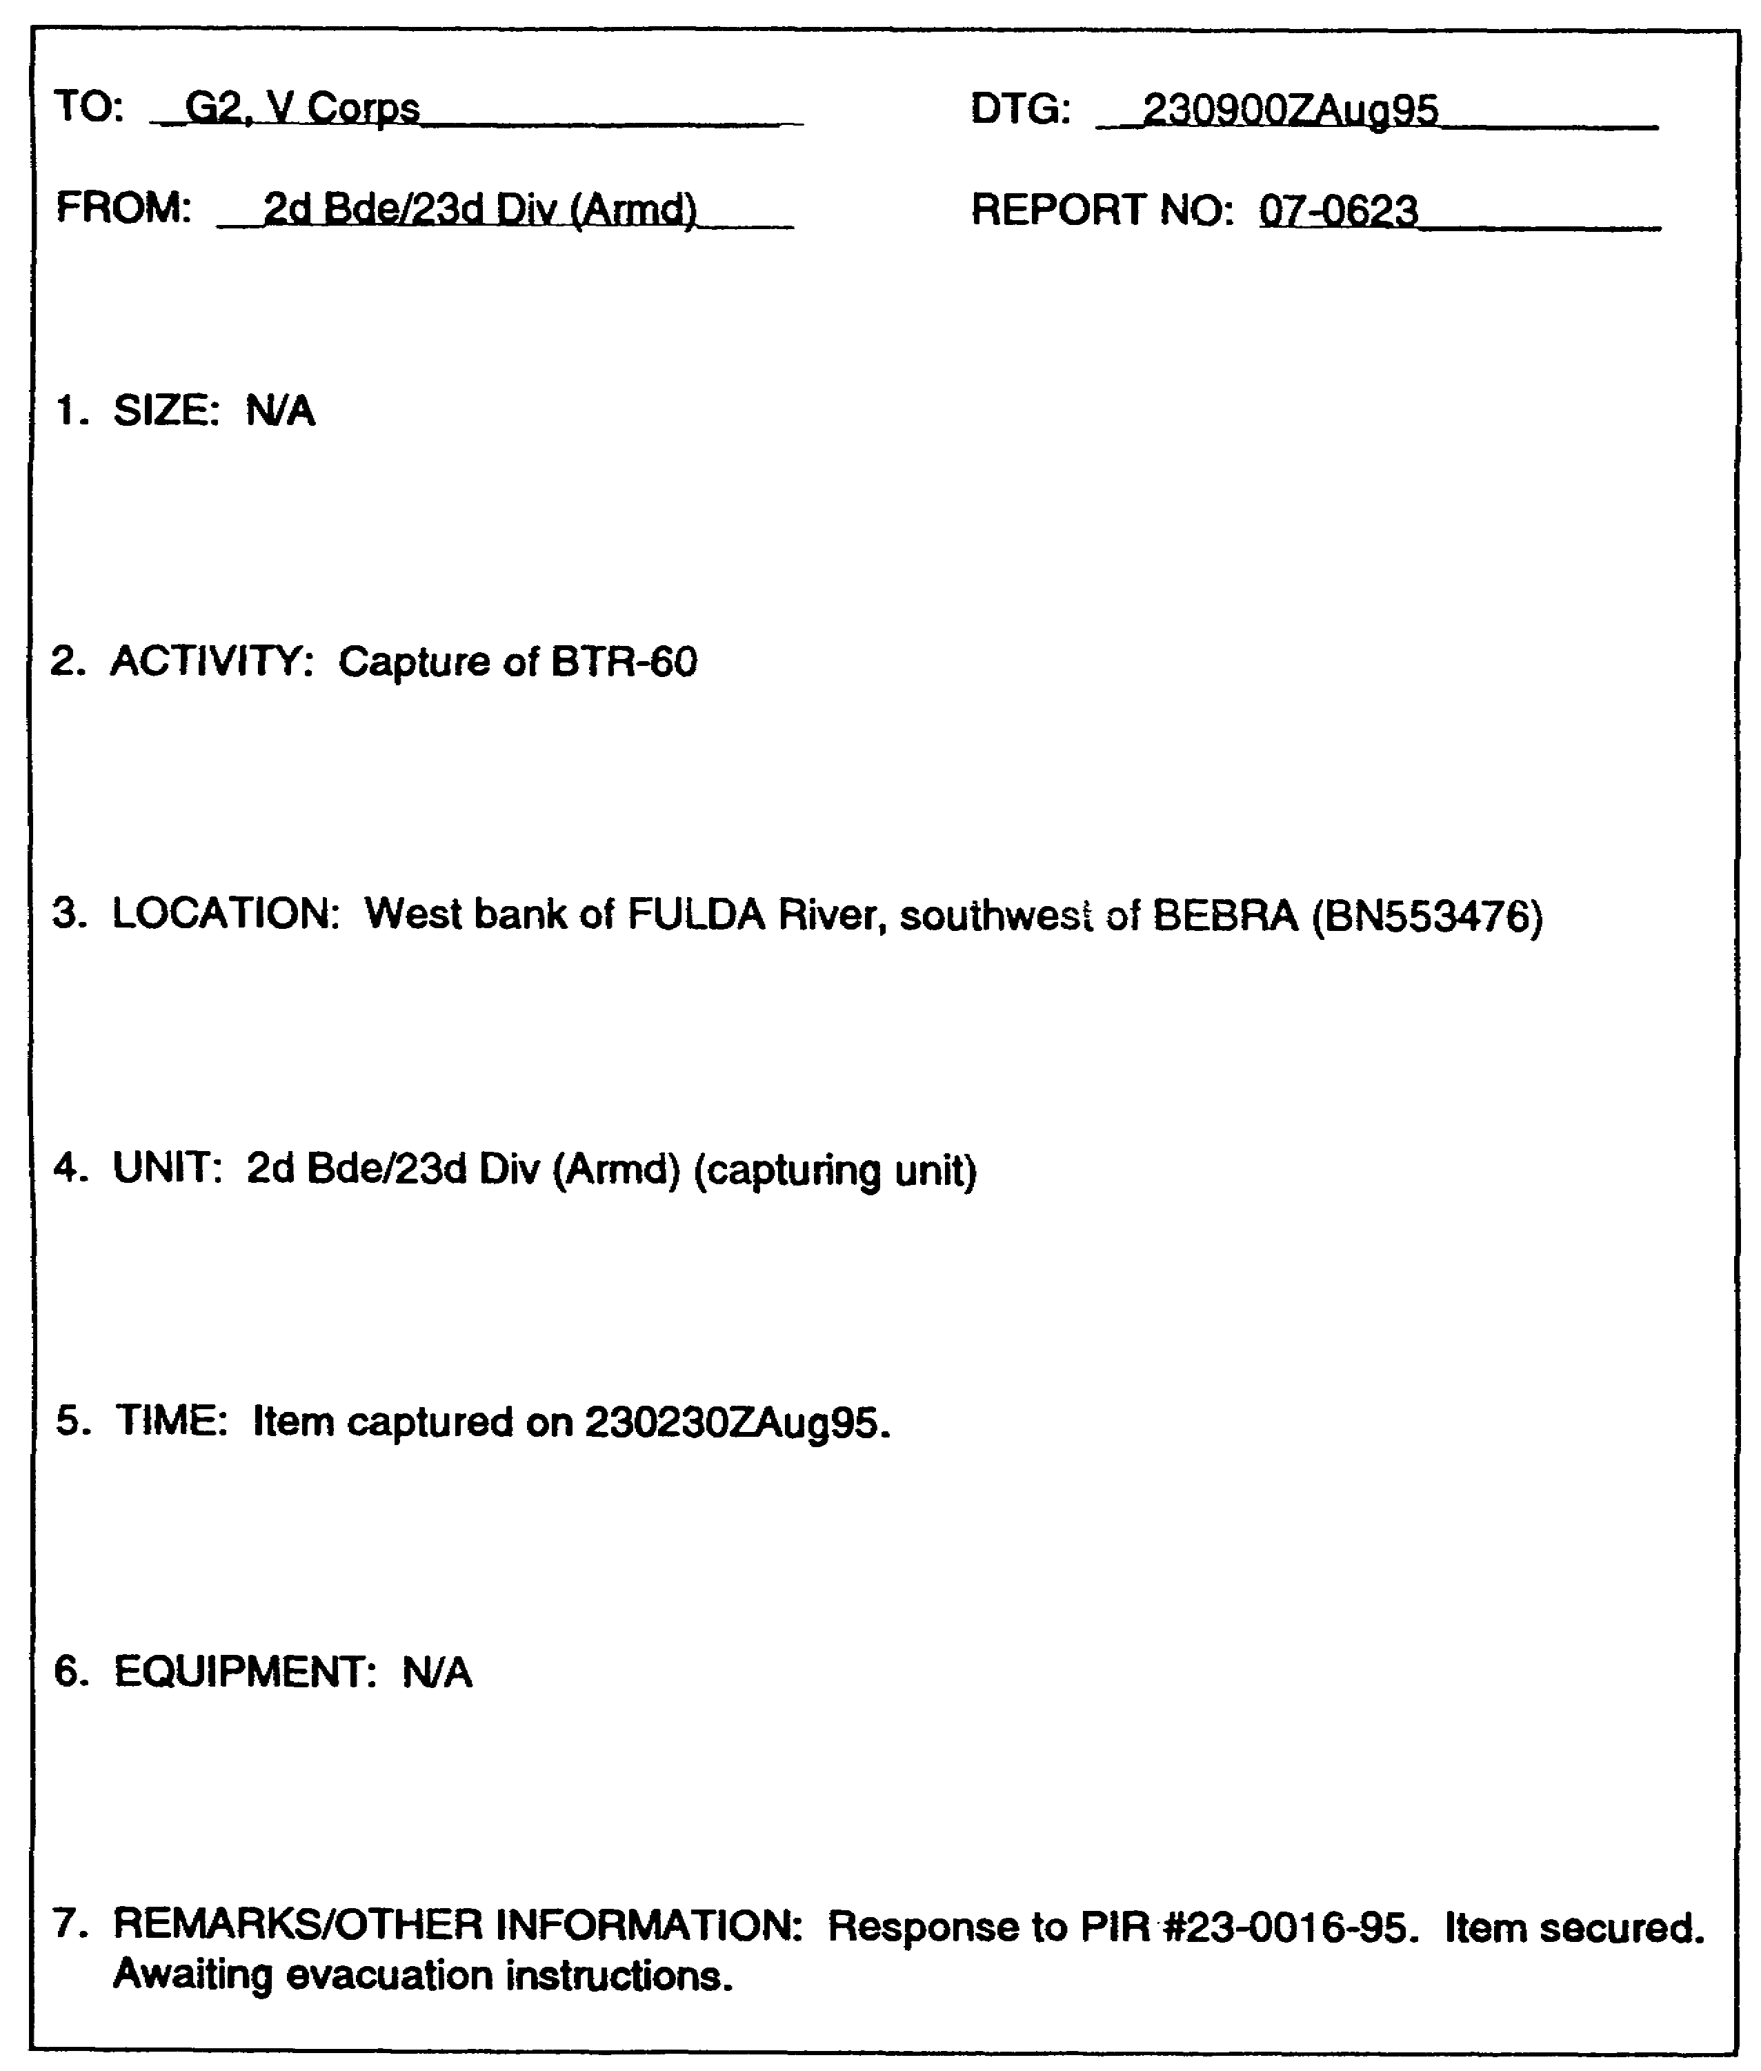

Figure 3-4. Sample Format for a SALUTE Spot Report.

3-13 IT 0425

PRELIMINARY TECHNICAL REPORT

Corps TECHINT teams prepare a PRETECHREP on all captured foreign materiel after preliminary screening. This report is transmitted by the quickest means through intelligence channels.

The PRETECHREP contains a general description of the equipment. It alerts tactical units to significant technical information of immediate tactical importance. It can also be used by the TECHINT teams for reporting inventories at collection points through intelligence channels so that location, quantities, and type of equipment can be monitored (see Figure 3-5).

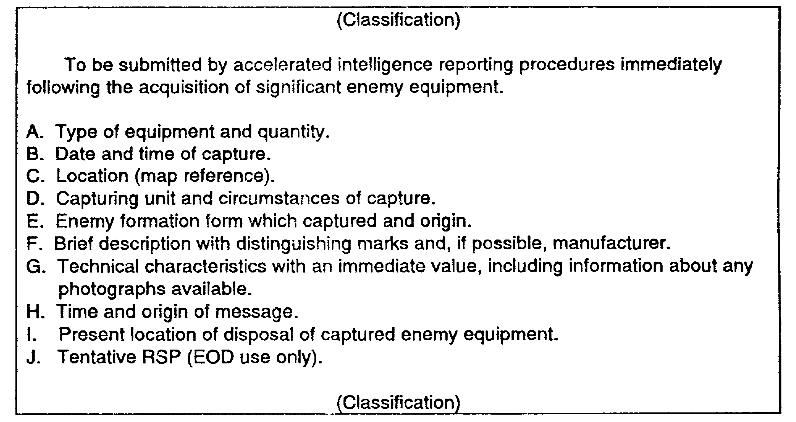

Figure 3-5. Format for a Preliminary Technical Report (PRETECHREP).

COMPLEMENTARY TECHNICAL REPORT

The COMTECHREP (types A, B, and C) is prepared by TECHINT teams operating in a corps area in support of corps elements. The COMTECHREP is submitted after complementary examination. It supplements information given in the PRETECHREP.

COMPLEMENTARY TECHNICAL REPORT - TYPE A

The COMTECHREP A is provided to Air Force TECHINT. Air Force teams usually are not on the scene of captured or downed enemy aircraft before destruction, recapture, or loss. Army TECHINT personnel, usually the first persons on the scene, will examine the materiel and submit a COMTECHREP Type A. This report often constitutes the only information that can be provided to Air Force TECHINT.

IT 0425 3-14

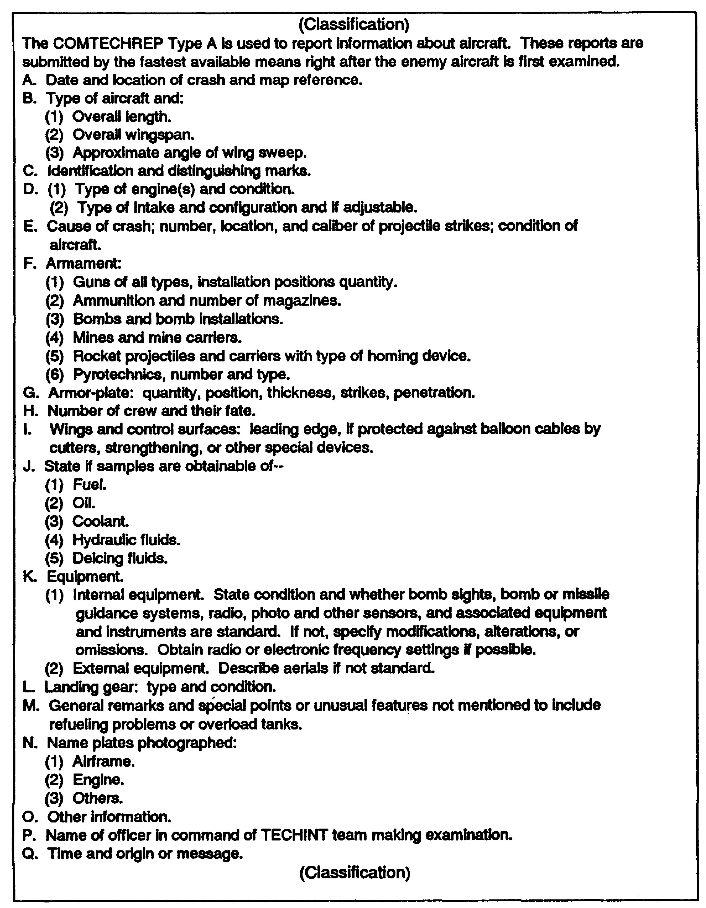

Figure 3-6. Format for a Complementary Technical Report
(COMTECHREP), Type A

3-15 IT 0425

If enemy naval materiel is acquired, Type A report format can be modified for reporting such acquisition, see Figure 3-6.

COMPLEMENTARY TECHNICAL REPORT TYPE B

The COMTECHREP Type B is used to report information about explosive ordnance. TECHINT teams prepare these reports; as do EOD personnel. However, EOD personnel only prepare them in the absence of a TECHINT team or when requested by G2s or their representatives. This report must be as complete and detailed as possible. EOD personnel prepare and send this report by the fastest means through the EOD control unit to the TECHINT unit as soon as the initial examination is completed.

The rule of thumb is to complete all of the items in the report that you have information for and to strive for the most complete report possible. However, when a detailed report might result in serious delay and the report Is of significant or new items of extreme urgency, complete only paragraphs A-E, L(1), Y and AA of COMTECHREP Type B in the initial priority message.

Additional paragraphs of particular importance, for example, those referring to safety (U) or design (M) may be included at the originator's discretion. Paragraph AA should state an estimate of the time required for a detailed report to be completed.

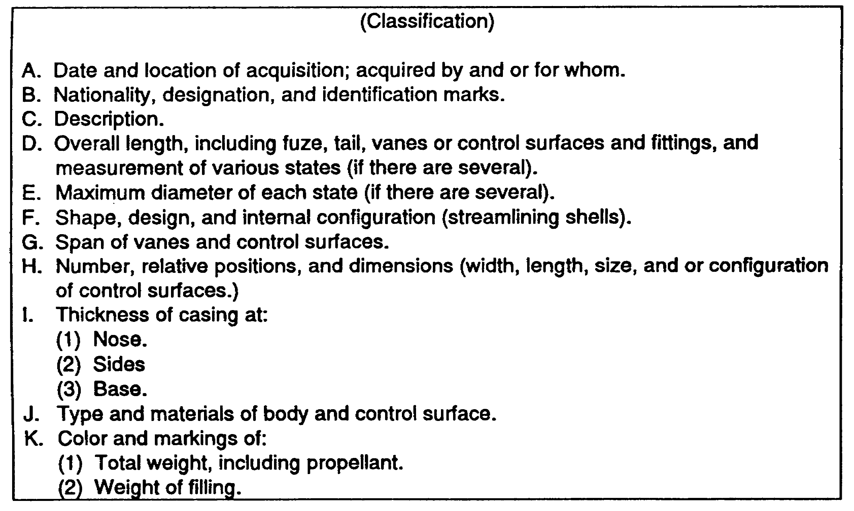

Figure 3-7. Format for Complementary Technical Report
(COMTECHREP), Type B.

IT 0425 3-16

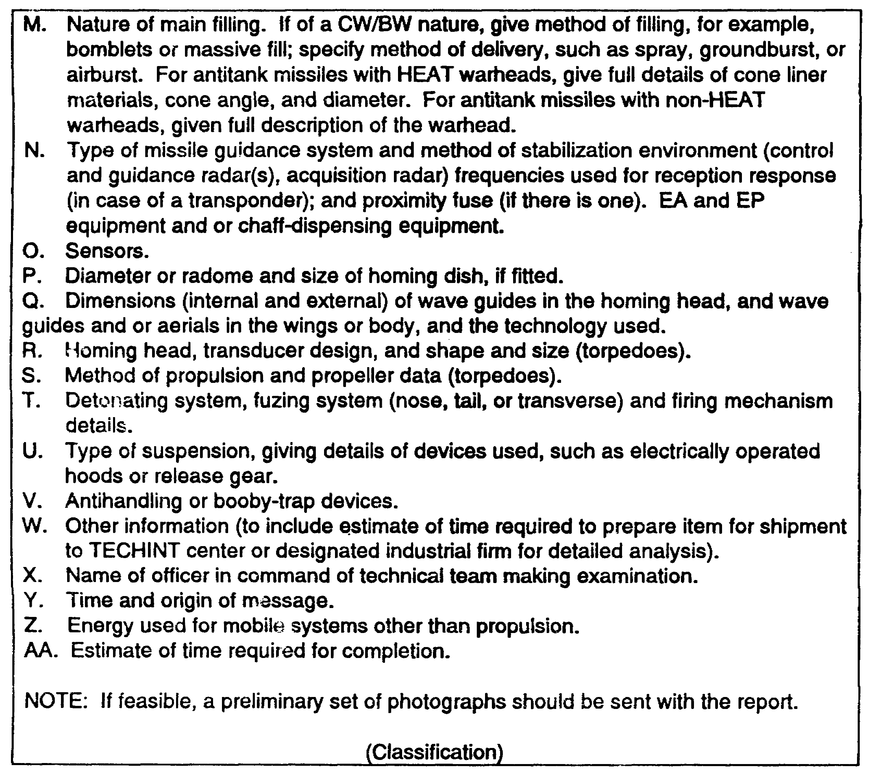

Figure 3-7. Format for Complementary Technical Report
(COMTECHREP), Type B (continued).

COMPLEMENTARY TECHNICAL REPORT TYPE C

The COMTECHREP Type C is used to report items not reported under COMTECHREP Types A and B. COMTECHREP Type C is submitted within 72 hours after an item of captured equipment, not covered under Types A and B, is acquired.

3-17 IT 0425

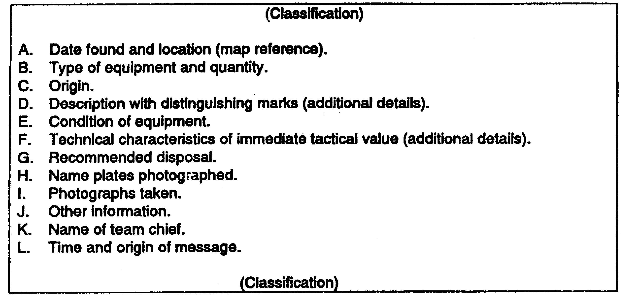

Figure 3-8. Format for Complementary Technical Report
(COMTECHREP), Type C.

DETAILED TECHNICAL REPORT

The DETECHREP is usually prepared by the CMEC. It is prepared and submitted by the proper authority or specialist team after detailed initial exploitation of captured equipment or materiel is completed. This exploitation takes place in the rear area. This report has no set format. The flag word 'DETECHREP" should be used as the report identifier, and must include data identifying CEE and its disposition.

TRANSLATION REPORT

The translation report is prepared on all captured enemy documents that might answer the command's PIR and IR. Prisoner of war interrogation (IPW) units normally prepare translation reports.

SPECIAL TECHNICAL REPORT

The special technical report is used by the EACIC to provide input to studies and plans for the G2. It contains special information on items of significant intelligence interest. No format is prescribed; the content is governed by the nature of the TECHINT desired by EACIC.

IT 0425 3-18

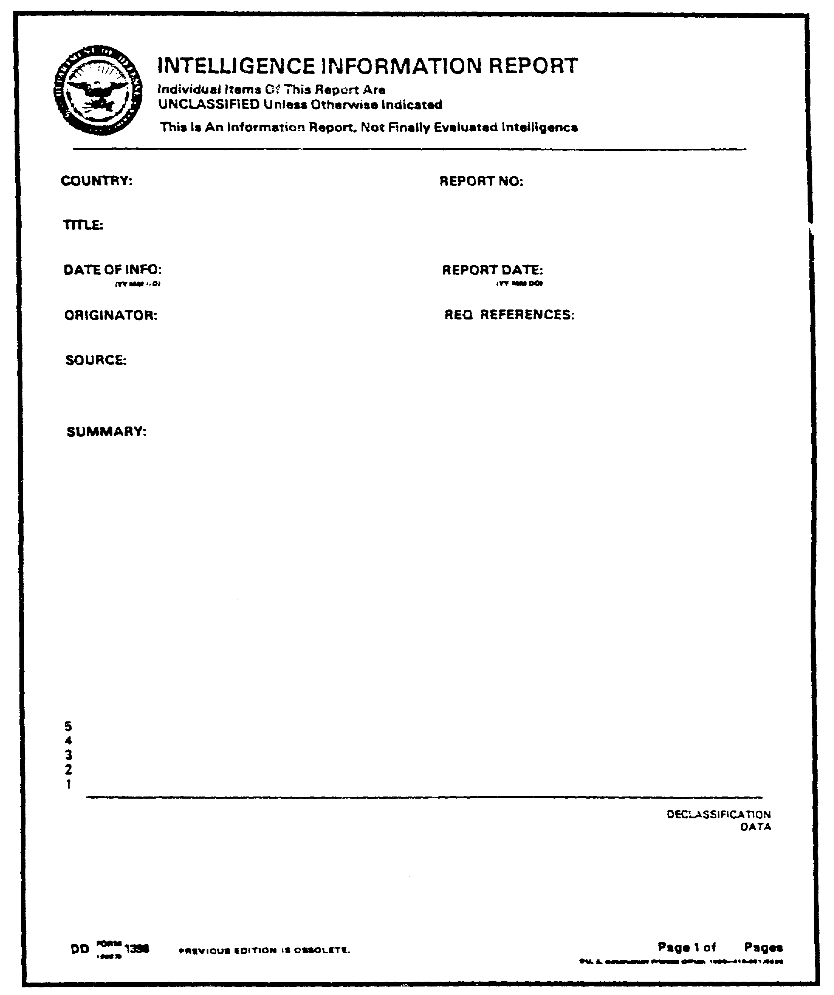

Figure 3-9. Intelligence Information Report.

3-19 IT 0425

NATO UNCLASSIFIED

ANNEX A TO STANAG 2084
(EDITION NO. 3)

TYPES OF CAPTURED ENEMY EQUIPMENT

Types of enemy equipment to be collected and examined by Technical Intelligence Teams. (New equipment or equipment in the process of development ("significant equipment") are the main concern of these teams.)

1. Army Equipment: COMTECHREP

a. Guided missiles.
b. Ammunition, all types including mines,
demolition, pyrotechnics and chemical.
c. Infantry weapons.
d. Sabotage equipment.
e. Armored fighting vehicles (AFVs). Type B
f. Military vehicles excluding AFVs. See Annex
g. Artillery, including antitank, antiaircraft, D (DofA)
and field rocketweapons.
h. Guides missile launching systems.
i. Engineering, amphibious and river crossing.
j. Electronics, infrared detections, and
communication equipment.
k. Airborne equipment.
i. Special weapons, including nuclear, biological
and chemical warfare equipment, flame and
incendiary weapons, equipment for dispersion
of chemical and biological warfare agents, Type C
together with protective devices. See Annex
m. Miscellaneous equipment: E (DofA)
(1) Camouflage equipment.
(2) Clothing and personal equipment.
(3) Medical equipment.
(4) Rations.

2. Air Force Equipment:

a. Aircraft, airframe and power plant.
b. Airborne armament and ammunition, bomb sights,
gun sights and photographic equipment.
c. Airborne radio and electronic equipment.

IT 0425 3-20

d. Miscellaneous airborne equipment, including
instruments and controls, dinghies, parachutes
and other safety equipment.
e. Ground equipment and installations.
f. Fuels, lubricants, greases and propellants.
g. Guided missiles and associated equipment.
h. Equipment for dispersion of chemical and
biological warfare agents.
i. Miscellaneous equipments:
(1) Flying clothing equipment, including
G-suits, pressure breathing equipment,
etc.
(2) Medical equipment and flying rations.

3. Navy Equipment

a. Ships.
b. Missiles and launching systems.
c. Shipboard ordnance, including guns, fire control equipment, i.e. radar, rangefinders, stable elements, range keepers, spotters' telescopes, gun mounts end turrets, ammunition hoists, rammers, fuses, fuse setters, recoil mechanisms, weapons of all types, including Hedgehogs, Mousetraps, Weapon "A" equivalents, Limbo types, depth charge racks and "Y" and "K" gun launchers; torpedoes and torpedo tubes, including Anti-Submarine Warfare (ASW) launchers; rockets and rocket launchers.
d. Sea mines (all types, including moored, bottom and floating; contact and influence).
e. Harbor defense equipment, including nets, booms, alerting devices, net tenders.
f. Navy electronics, infrared, detection and communication equipment, sonars, fathometers and sonobuoys.
g. Fuels, lubricants, greases, and propellants.
h. Special weapons, including chemical warfare equipment, flame and incendiary equipment for dispersion of chemical and biological warfare agents, together with protective devices such as clothing, gas masks and canisters; salt water spray deck washing equipment for NBC protection.
I. Medical supplies and medical instruments.
j. Demolition and sabotage equipment, underwater demolition team (UDT) equipment (sleds, masks, etc.).
k. Naval engineering systems, including main propulsion machinery, nuclear plant steam or gas turbines, boilers, diesel engines, auxiliary equipment including motor generators, heat exchanges, pumps, evaporators, fuel oil systems for boilers and diesel engines including fuel pumps and fuel oil heaters; pressure gauges, boiler accessories including safety valves, steam control valves, gauge glasses, feed water check valves, propellers, hull zincs, refrigerating machinery, submarine storage batteries and their ventilating equipment, ammeters, voltmeters, amp/hr meters; steering engines, engine room telegraph systems, submerged atmospheric gas analyzers, C0₂ scrubbers, compressors,

3-21 IT 0425

and ship's underwater logs; samples of metals used in shipbuilding and any information (description) of welding techniques used in shipbuilding.
I. Hydrofoil and hovercraft, small boats and boat handling equipment, life rafts and signal apparatus or any of their components such as hydrofoil foils.
m. Anchors, chains, windlasses, winches, fueling and transfer at sea rigs, and cargo handling gear.
n. Hydrographic survey ship's equipment, including high altitude research rockets and their launching equipment, sonars and fathometers, sea bottom sampling gear such as drags and coring equipment, deep sea anchors, sea current measuring devices, biological sampling equipment, Nansen bottles, possible helicopters, and other equipment such as laboratory instruments.

NOTE: (1) Although cryptographic material is not specifically mentioned in the above lists, technical intelligence teams also are responsible for the collection of such material. Special instructions for the handling of this equipment are to be issued by the appropriate NATO command.

(2) Where no requirement exists for permanent Naval Technical Intelligence Teams, such groups may be set up on an ad hoc basis.

IT 0425 3-22

LESSON 3

PRACTICE EXERCISE

The following material will test your grasp of the material covered in this lesson. There is only one correct answer for each item. When you have completed the exercise, check your answers with the answer key that follows. If you answer any item incorrectly, study again that part of the lesson which contains the portion involved.

SECTION/UNIT/ORGANIZATION RESPONSIBLE FOR:

1. Complimentary Technical A. Oral or written report for rapid
Report – COMTECHREP _____ reporting of captured foreign
materiel.

2. Detailed Technical B. Supplements information given
Report - DETECHREP _____ in the PRETECHREP.

3. Spot Report - SPOTREP _____ C. Agreement on handling and
reporting of captured enemy
equipment and documents.

4. Preliminary Technical D. Prepared by corps TECHINT
Report - PRETECHREP _____ teams and contain a general
description of the equipment.

5. Special Technical E. Prepared after detailed initial
Report _____ exploration of captured
equipment or materiel is complete.

6. STANAG 2084 _____ F. Used by EACIC to provide input
to studies and plans for the G2.

3-23 IT 0425

LESSON 3

PRACTICE EXERCISE

ANSWER KEY AND FEEDBACK

Item Correct Answer and Feedback

1. B. The COMTECHREP is submitted after complementary examination. It supplements information given in the PRETECHREP (page 3-14, para 3).

2. E. The DETECHREP is usually prepared by the CMEC. It is prepared and submitted by the proper authority or specialist team after detailed initial exploration of captured equipment or materiel is completed. (page 3-18, para 1).

3. A. The SPOTREP is an oral or written report which is prepared by the capturing unit and/or intermediate command echelon for rapid reporting of the acquisition of captured or abandoned foreign materiel through their next higher headquarters to the TECHINT element (page 3-12, para 2).

4. D. Corps TECHINT teams prepare a PRETECHREP on all captured foreign materiel after preliminary screening. The PRETECHREP contains a general description of the equipment (page 3-14, para 1).

5. F. The special technical report is used by the EACIC to provide input to studies and plans for the G2 (page 3-18, para 3).

6. C. STANAG 2084 is the agreement on handling and reporting of captured enemy equipment and documents (page 3-12, para 2).

IT 0425 3-24

ACRONYMS

AC Active Component

ACE Analysis and Control Element

AFMIC Armed Forces Medical Intelligence Center

AIA Army Intelligence Agency

AMC Army Materiel Command

APG Aberdeen Proving Grounds

ASIS All-Source Intelligence Section

CA Civil Affairs

CCMEC Combined Captured Materie Exploitation Center

C-E Communications and electronics

CEE Captured Enemy Equipment

CEM Captured Enemy Materiel

CMEC Captured Materiel Exploitation Center

COMMZ Communications Zone

CONUS Continental United States

COSCOM Corps Support Command

COMTECHREP Complementary Technical Report

DA Department of the Army

DCSINT Deputy Chief of Staff for Intelligence

DETECHREP Detailed Technical Report

DIA Defense intelligence Agency

DOD Department of Defense

EA Electronic Attack

A-1 IT 0425

EAC Echelons Above Corps

EACIC Echelons Above Corps Intelligence Center

ECB Echelons Corps and Below

EOD Explosive Ordnance Disposal

EP Electronic Protection

EPW Enemy Prisoner of War

FMA Foreign Materiel Acquisition

FME Foreign Materiel Exploitation

FMEP Foreign Materiel Exploitation Program

FMIG Foreign Materiel Intelligence Group

FMME Foreign Medical Materiel Exploitation

FMP Foreign Material Program

FSTC Foreign Science and Technology Center

FTD Foreign Technology Division

HQDA Headquarters Department of the Army

HUMINT Human Intelligence

ID Identification

INSCOM Intelligence and Security Command

IPW Interrogation of Prisoner of War

IR Information Requirements

ISE Intelligence support element

ITAC Intelligence and Threat Analysis Center

SOl Signal Operation Instructions

IT 0425 A-2

